

Data Lake and Data Warehouse
Year 2 (2025/26), Semester 4
SCHOOL OF INFOCOMM TECHNOLOGY
Diploma in Data Science

ASSIGNMENT
Part A

Module Group: | P02
Team No: | Team B
Student Leader Name: | Lee Yeaw Min (S10259184)
Student 2 Name: | Simon Saw Yong Ping (S10267332)
Student 3 Name: | Liu Yiyang (S10259130K)
Student 4 Name: | NG N G (S10270342)
Student 5 Name: | Loy Xie Jing (S10257450A)



Data Lake and Data Warehouse
Year 2 (2025/26), Semester 4

SCHOOL OF INFOCOMM TECHNOLOGY
Diploma in Data Science

ASSIGNMENT (Part A)

Part A – 35 Marks (Team)
Part B – 50 Marks (Individual) to be released in Term 2
Part C – 15 Marks (Team + Individual Presentation) in Week 16 or 17

Weightage: | 40%
Individual/Team/Both: | Both
Format: | Font Arial  Font Size 11, 1.5 spacing
Deadline: | Report & Excel File:  30 Jan 2026, 2359hrs  Softcopy via POLITEMall  Part A and Part B Presentations will take place during Week 16 and Week 17, to be scheduled by Tutor.

Scenario Overview 3
Purposes of JSON files 3
Customer Master 3
Vehicle Master 4
Rental Transactions 5
Damage Transactions 5
Relationship between Master and Transactions 6
JSON Data File Structures 7
Customer Master 8
Vehicle Master 11
Rental Transaction 12
Damage Transaction 14
Proof Of Uploaded Files 16
@JSON_STAGE 17
@IMAGES_STAGE 17
@VIDEOS_STAGE 18
Proof Of File Formats 19
Customer Master 20
Vehicle Master 20
Rental Transaction 21
Damage Transaction 21
SQL Scripts 22
Customer Master 23
1. Set Context 23
2. Create File Format 23
3. Create Table By Flattening 23
4. Verify All Customer Master Records 26
5. Verify Total Record Count 27
6. Suspend Warehouse 27
Vehicle Master 28
1. Set Context 28
2. Create File Format 28
3. Flatten Vehicle Master to table 29
4. Verifying table records (sampling 5 records) 32
5. Count total records of Vehicle Master 32
6. Checking a specific vehicle information on Vehicle Master 33
7. Session Suspend 34
Rental Transaction 34
1. TYPE = 'JSON' 35
2. STRIP_OUTER_ARRAY = FALSE 35
3. COMMENT = 'File format for rental data JSON' 35
4. Flattening the JSON structure 37
5. Booking and customer details 37
6. Rental dates with safe type conversion 37
7. Delete from Rental_Master_Flattened 38
8. Where Customer_ID Is Null 38
9. Verify the final data 38
10. Remove the session query tag 38
11. Ensure minimal warehouse size 39
12. Suspend the warehouse 39
Damage Transaction 39
Table Joins (Damage) 44
Table Joins (Master & Transaction) 48
File Directory / Scoped URLs 54
Final Curated Dataset 56
Exported CSV Snippet 58
References 59
Images Sourced 60

Scenario Overview

Vehicle Rental Bookings and Damage Reports

Our group’s assigned scenario is to analyse rental patterns and assess post-rental vehicle damages using photos and videos. By leverage a cloud-based data platform like Snowflake, rental companies can store their semi-structured data (JSON) and unstructured data (images and videos) and retrieve them with ease.

This assists rental companies in actively monitoring their rental transactions to identify and segment customers based on their usage frequency and preferences. In addition, damages caused to rental vehicles can be accurately tracked by rental companies since all the supporting documents such as images and videos taken by service technicians can be retrieved when querying a specific customer.

Purposes of JSON files

Customer Master

Customer Master is the core, non-transactional information about every customer of the rental company. It forms a trusted "single source of truth" to identify a customer. This is the essential data (e.g. customer name, address, phone number) that's reused across systems, unlike transactional data (e.g. rental booking, damage) which is regularly updated with new records.

Customer Master ensures that each customer has one unique CUSTOMER_ID and that customer attributes are consistent across all rental bookings and damage report transactions. Without it, separate rental transactions cannot be linked back to the same person.

Since the rental company’s goal is to analyse rental patterns based on customer behaviour, this would require customer-level grouping. With Customer Master, we can analyse patterns based on:
- rentals by age group (derived from DOB)
- rentals by region/planning area
- rentals by risk category
- rentals by driving experience years
- rentals by eligible vehicle classes (SUV vs Sedan preference)

This helps the rental company tailor their products and services according to each customer’s need.

Customer Master also links transactional data like rental bookings and damages report through its primary key CUSTOMER_ID. Therefore, the rental company can produce analysis like:
- damage probability based on customer risk profile
- damage severity based on driving experience
- repeat offender detection (same customer repeatedly involved in damages)

Having a Customer Master helps it identify customers associated with higher severity damages and form reasonable hypothesis such as the relationship between demerit points accumulated and damages and if certain offence types lead to higher damage rates. This is important for considerations such as: deposit policy, customer risk scoring and fraud detection.

Customer Master also reduces data duplication and improves data governance since storing customer information within transaction records may cause inconsistent updates e.g. customer changed phone number, but old bookings still show old number. Customer Master prevents this issue by storing customer details only once.

Customer Master supports other operational processes for rental companies such as:
- customer verification (licence verification status)
- insurance checks
- emergency contacts
- blacklisting / suspending customers

Vehicle Master

Vehicle Master is the core, non-transactional information about every vehicle within the fleet of the rental company. It forms a trusted "single source of truth" to identify a rental vehicle. Every rental booking and damage report must point to a specific vehicle. To acquire vehicle details from rental booking and damage transactions, they only need to reference the primary key VEHICLE_ID.

Vehicle Master enables rental companies to analyse rental patterns based on vehicle types and answer important business questions such as:
- which brand/model is rented most
- rentals by vehicle category (SUV vs Sedan)
- demand for hybrid vs petrol vehicles
- mileage vs rental frequency

Without Vehicle Master, we can’t group rental bookings by vehicle characteristics.

Vehicle Master is also important for damage analytics since damage report transactions must be tied to a vehicle for rental companies to track activities such as:
- Which vehicles are damaged most frequently?
- Which model type has higher repair cost?
- Which vehicles are “repeat damage” vehicles?

Vehicle Master ensures that unstructured data from damage report transactions i.e. photos and videos taken of the damages caused to vehicles is well integrated and can be accessed via queries through scoped URLs. This allows rental companies to assess and analyse the evidence media.

Since Vehicle Master incorporates geo-spatial context such as depot coordinates, geohash, service zones, operational routes, it enables location-based analysis such as:
- rental demand by depot
- damage hotspots by region
- depot performance (East vs Central)
- route-based risk (“Airport to CBD route has more incidents”)

Vehicle Master also supports maintenance and operation analytics since it stores maintenance and servicing fields such as:
- last service date
- next service due
- service centre coordinates

This allows rental companies to address important business questions like:
- Do vehicles overdue for service have higher breakdown/damage rate?
- Maintenance schedule vs booking utilisation
- Do high utilisation vehicles need more frequent servicing?

Rental Transactions

Unlike Customer and Vehicle Masters which are dimension tables, rental booking transactions are stored in a fact table since they capture details of a rental event. It records:
- Booking ID
- Customer ID
- Vehicle ID
- pickup/dropoff dates & location
- price, days, total price
payment status
route/zone used

Without rental transactions, there would be no rental patterns to analyse.

Rental transactions enable rental companies to answer important business questions such as:
- Which months have the most rentals?
- Peak rental duration (short vs long rentals)
- Demand by zone/depot
- Revenue trends by time
- Vehicle category popularity

Rental transaction is also the bridge that links Customer and Vehicle Master since it stores the foreign keys CUSTOMER_ID and VEHICLE_ID.

CUSTOMER_MASTER (dimension) ← RENTAL (fact) → VEHICLE_MASTER (dimension)

Rental transactions are important for damage analysis as well since it contains the foreign key REPORT_ID to link to damage report transactions. This is also because damages will only happen if there’s a rental transaction record. Without a rental booking, there will be no damages reported. It allows rental companies to:
- link a damage report to the exact booking
- identify who rented the vehicle before damage
- analysing which routes/zones have more damage cases

Damage Transactions

Damage report transactions represent a post-rental event where a vehicle is found damaged and the company records the details for investigation, costing, and follow-up actions. Just like rental booking transactions, damage report transactions are stored as a fact table as well. Damage reports capture what happened to the vehicle including:
- REPORT_ID (unique incident)
- VEHICLE_ID, CUSTOMER_ID, BOOKING_ID (foreign keys)
- date & location
- damage type + description
- affected areas and severity
- actions taken (police report, insurance notified)
- status (Under Review / Closed)

Damage transactions help rental companies assess post-rental vehicle damages through photos, videos and report details. The rental company can generate damage-related outputs such as:
- damage type (scratch/dent/broken mirror)
- severity score (1–5)
- estimated loss due to repair

Having a damage report transaction data enables rental companies to analyse financial impacts due to rental vehicle damages since it includes fields such as ESTIMATED_LOSS per damaged area and TOTAL_ESTIMATED_LOSS.

This lets rental companies address business questions such as:
- total damage cost over time
- average damage cost per incident
- cost by vehicle type / model / age
- cost by zone/route

Since damage transactions references primary keys in other tables like Customer Master, Vehicle Master and Rental Transactions, it enables the rental companies to identify risk patterns in different categories:

- Customer risk
- Which customers have repeated incidents?
- Damage rate per customer
- High-risk customer profiles

- Vehicle risk
- Which vehicles get damaged most often?
- Is VEH005 frequently damaged?

- Location risk
- Which depot has the most damage reports?
- Is vandalism more common in Woodlands?

Furthermore, damage transactions allow rental companies to track operational actions performed in response to the damage report i.e. police report filed, insurance notified. It tracks the case lifecycle through STATUS i.e. Under Review, Closed.

Damage transactions can be linked to rental booking transactions since it contains the foreign key BOOKING_ID. Therefore, damages can be easily attributed to rentals.

Relationship between Master and Transactions

Dataset | Type | Primary Key | Links To | Relationship
Customer Master | Master (Dimension) | CUSTOMER_ID | Rental Booking | 1 Customer → Many Bookings
Customer Master | Master (Dimension) | CUSTOMER_ID | Damage Report | 1 Customer → Many Damage Reports
Vehicle Master | Master (Dimension) | VEHICLE_ID | Rental Booking | 1 Vehicle → Many Rentals
Vehicle Master | Master (Dimension) | VEHICLE_ID | Damage Report | 1 Vehicle → Many Damage Reports
Rental | Transaction (Fact) | BOOKING_ID | Damage Report | 1 Booking → 0/Many Damage Reports
Damages | Transaction (Fact) | REPORT_ID | Rental Booking | Many Reports → 1 Booking

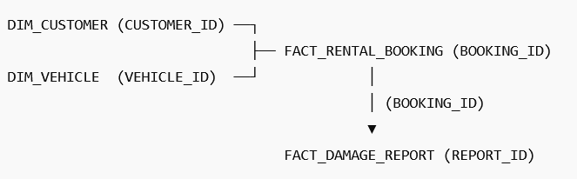

JSON Data File Structures

Customer Master
Sample Record:
"CUSTOMERS": [
{
"CUSTOMER_ID": "CUST001",
"ACCOUNT_METADATA": {
"CREATED_DATE": "2022-11-10",
"LAST_UPDATED": "2024-12-20",
"STATUS": "ACTIVE"
},
"PERSONAL_INFO": {
"FULL_NAME": "Alex Tan",
"NRIC": "S8612345L",
"DATE_OF_BIRTH": "1986-01-01"
},
"CONTACT": {
"PHONE_NO": "91234567",
"OFFICE_NO": "61234567",
"EMAIL": "alex.tan@email.com",
"EMERGENCY_CONTACTS": [
{
"NAME": "John Tan",
"RELATIONSHIP": "Brother",
"PHONE": "90011233"
}
]
},
"ADDRESS": {
"RESIDENTIAL": {
"CITY": "Singapore",
"POSTAL_CODE": "560123",
"COORDINATES": {
"LATITUDE": 1.3542,
"LONGITUDE": 103.8421
},
"GEOHASH": "w21z7u8p",
"GEO_CONTEXT": {
"COUNTRY": "Singapore",
"REGION": "North-East",
"PLANNING_AREA": "Hougang",
"SUBZONE": "Lorong Ah Soo"
}
}
},
"DRIVER_LICENCE": {
"LICENCE_NO": "S1234567A",
"ISSUE_COUNTRY": "SG",
"ISSUE_DATE": "2023-01-01",
"DRIVING_EXPERIENCE": {
"YEARS_OF_EXPERIENCE": 8,
"INTERNATIONAL_PERMIT": false,
"ELIGIBLE_VEHICLE_CLASSES": [
"SUV",
"Sedan"
]
},
"VERIFICATION": {
"VERIFIED": true,
"VERIFIED_DATE": "2024-12-01",
"VERIFICATION_METHOD": "GOV_API"
}
},
"INSURANCE_DETAILS": {
"INSURANCE_COMPANY": "NTUC Income",
"INSURANCE_AGENT": "David Lee",
"COVERAGE_PLAN": {
"PLAN_NAME": "Comprehensive Plus",
"COVERAGE_AMOUNT": 50000
}
},
"RISK_PROFILE": {
"DEMERIT_POINTS": 4,
"TRAFFIC_OFFENCES": [
{
"OFFENCE_TYPE": "Speeding",
"OFFENCE_DATE": "2023-08-15",
"POINTS": 4
}
],
"RISK_CATEGORY": "MEDIUM"
}
}

Nesting Depth | Key | Value / Type | Notes
0 | CUSTOMERS | Array of objects | Top-level array, each element is a customer object
1 | CUSTOMER_ID | String | Unique customer identifier
1 | ACCOUNT_METADATA | Object | Contains account-related info
2 | CREATED_DATE | String (YYYY-MM-DD) | Date account created
2 | LAST_UPDATED | String (YYYY-MM-DD) | Date of last update
2 | STATUS | String | Account status, e.g., ACTIVE
1 | PERSONAL_INFO | Object | Customer personal info
2 | FULL_NAME | String (Alex Tan) | Full name of customer
2 | NRIC | String | Identification number
2 | DATE_OF_BIRTH | String (YYYY-MM-DD) | Date of birth
1 | CONTACT | Object | Contact information
2 | PHONE_NO | String | Personal phone number
2 | OFFICE_NO | String | Office phone number
2 | EMAIL | String | Email address
2 | EMERGENCY_CONTACTS | Array of objects | Emergency contacts (can have multiple)
3 | NAME | String | Name of emergency contact
3 | RELATIONSHIP | String | Relationship to customer
3 | PHONE | String | Contact phone number
1 | ADDRESS | Object | Customer residential address
2 | RESIDENTIAL | Object | Residential details
3 | CITY | String | City
3 | POSTAL_CODE | String | Postal code
3 | COORDINATES | Object | Latitude and longitude coordinates
4 | LATITUDE | Float | Latitude value
4 | LONGITUDE | Float | Longitude value
3 | GEOHASH | String | Geohash of location
3 | GEO_CONTEXT | Object | Geographic context
4 | COUNTRY | String | Country
4 | REGION | String | Region
4 | PLANNING_AREA | String | Planning area
4 | SUBZONE | String | Subzone
1 | DRIVER_LICENCE | Object | Driver licence information
2 | LICENCE_NO | String | Licence number
2 | ISSUE_COUNTRY | String | Country issued
2 | ISSUE_DATE | String (YYYY-MM-DD) | Licence issue date
2 | DRIVING_EXPERIENCE | Object | Driving experience info
3 | YEARS_OF_EXPERIENCE | Integer | Number of years
3 | INTERNATIONAL_PERMIT | Boolean | True/False
3 | ELIGIBLE_VEHICLE_CLASSES | Array of strings | Vehicle types allowed, e.g., ["SUV","Sedan"]
2 | VERIFICATION | Object | Licence verification info
3 | VERIFIED | Boolean | True/False
3 | VERIFIED_DATE | String (YYYY-MM-DD) | Verification date
3 | VERIFICATION_METHOD | String | E.g., "GOV_API"
1 | INSURANCE_DETAILS | Object | Insurance info
2 | INSURANCE_COMPANY | String | Company name
2 | INSURANCE_AGENT | String | Agent name
2 | COVERAGE_PLAN | Object | Coverage details
3 | PLAN_NAME | String | Plan name
3 | COVERAGE_AMOUNT | Number | Coverage amount
1 | RISK_PROFILE | Object | Risk-related info
2 | DEMERIT_POINTS | Integer | Number of points
2 | TRAFFIC_OFFENCES | Array of objects | Past traffic offences
3 | OFFENCE_TYPE | String | Type of offence
3 | OFFENCE_DATE | String (YYYY-MM-DD) | Date of offence
3 | POINTS | Integer | Points incurred
2 | RISK_CATEGORY | String | Risk category, e.g., MEDIUM

Customer Master data is stored in a hierarchical JSON format where the root object contains a CUSTOMERS array, and each element in CUSTOMERS[] represents one complete customer profile identified by a unique CUSTOMER_ID as its primary key.

Within each customer record, the data is organised into nested objects including:
- ACCOUNT_METADATA (created date, last updated, status)
- PERSONAL_INFO (full name, NRIC, date of birth)
- CONTACT (phone, office number, email)
- ADDRESS.RESIDENTIAL (city, postal code, coordinates, geohash, and geo context)
- DRIVER_LICENCE (licence number, issue details, driving experience, verification)
- INSURANCE_DETAILS (company, agent, coverage plan)
- RISK_PROFILE (demerit points, risk category)

The structure also contains nested arrays such as:
- CONTACT.EMERGENCY_CONTACTS[]
- DRIVER_LICENCE.DRIVING_EXPERIENCE.ELIGIBLE_VEHICLE_CLASSES[]
- RISK_PROFILE.TRAFFIC_OFFENCES[]

The nested arrays may expand into multiple rows per customer when flattening in Snowflake due to row explosion occurring because of multiple elements within the array.

Vehicle Master
Sample Record:
{
"VEHICLE_ID": "VEH001",
"LICENSE_PLATE": "SBA1234A",
"BRAND_NAME": "Toyota",
"MODEL_TYPE": "Corolla Altis",
"MILEAGE_USED": 45230,
"REGISTRATION_DETAILS": {
"REGISTRATION_YEAR": 2020,
"VEHICLE_CATEGORY": "Sedan",
"FUEL_TYPE": "Hybrid"
},
"CURRENT_LOCATION": {
"DEPOT_NAME": "Changi Airport Depot",
"COORDINATES": {"LATITUDE": 1.3544, "LONGITUDE": 103.9894},
"GEOHASH": "w21z7u8p"
},
"SERVICE_ZONES": [...],
"OPERATIONAL_ROUTES": [...],
"MAINTENANCE_HISTORY": {...}
}
This master data provides vehicle information on
- Basic vehicle details (ID, plate, brand, model)
- Registration info (year, category, fuel type)
- Geospatial data (depot locations, coordinates, geohashes, service zones, routes)
- Maintenance tracking (service dates, centers)

Rental Transaction
Sample record:
{
"BOOKING_ID": "BKG91011",
"BOOKING_INFORMATION": {
"CUSTOMER_INFO": {
"CUSTOMER_ID": "CUST008"
},
"DATES": {
"PICKUP_DATE": "2024-06-10",
"DROPOFF_DATE": "2024-06-17"
},
"LOCATION": {
"PICKUP_LOCATION": {
"LOCATION": "Orchard Depot",
"COORDINATES": {
"LATITUDE": 1.3048,
"LONGITUDE": 103.8318
}
},
"DROPOFF_LOCATION": {
"LOCATION": "Orchard Depot",
"COORDINATES": {
"LATITUDE": 1.3048,
"LONGITUDE": 103.8318
}
}
},
"VEHICLE_TYPE": "Sedan",
"VEHICLE_ID": "VEH005",
"PRICE_PER_DAY": 55.0,
"NUMBER_OF_DAYS": 7,
"TOTAL_PRICE": 385.0,
"PAYMENT_STATUS": "Paid",
"REPORT_ID": "DR-20240618-002",
"ROUTE_ID": "RT005",
"ZONE_ID": "ZONE_CENTRAL_02"
}
}

Nesting depth | Key | Value / Type | Notes
0 | BOOKING_ID | String | Unique rental booking identifier
0 | BOOKING_INFORMATION | Object | Contains all rental-related details
1 | CUSTOMER_INFO | Object | Customer details
2 | CUSTOMER_ID | String | Unique customer identifier
1 | DATES | Object | Rental period details
2 | PICKUP_DATE | String (YYYY-MM-DD) | Rental start date
2 | DROPOFF_DATE | String (YYYY-MM-DD) | Rental end date
1 | LOCATION | Object | Pickup and drop-off locations
2 | LOCATION_NAME | String | Name of pickup/drop-off location
3 | COORDINATES | Object | GPS coordinates of pickup location
4 | LATITUDE | Number | Latitude of pickup location
4 | LONGITUDE | Number | Longitude of pickup location
2 | DROPOFF_LOCATION | Object | Vehicle drop-off location
1 | VEHICLE_TYPE | String | Type of vehicle rented
1 | VEHICLE_ID | String | Unique vehicle identifier
1 | PRICE_PER_DAY | Number | Daily rental price
1 | NUMBER_OF_DAYS | Number | Rental duration in days
1 | TOTAL_PRICE | Number | Total rental cost
1 | PAYMENT_STATUS | String | Payment state (e.g., Paid)
1 | REPORT_ID | String | Rental or damage report reference
1 | ROUTE_ID | String | Route identifier
1 | ZONE_ID | String | Operational zone identifier

Damage Transaction
Sample Record:
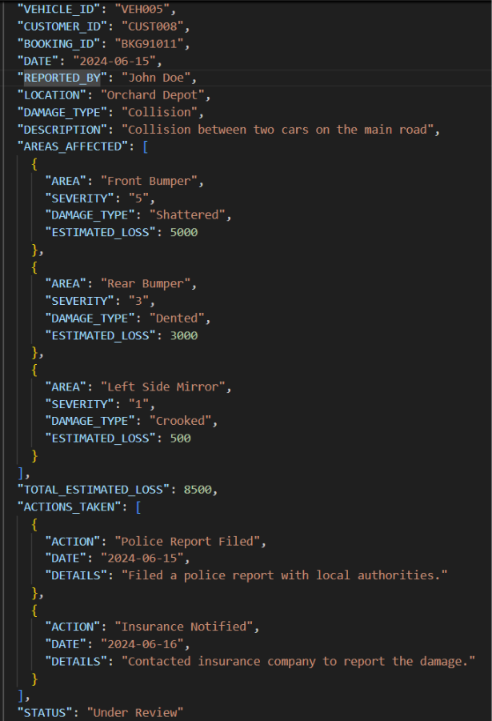

Purpose of the JSON Data File

The damage report JSON file is designed to capture comprehensive incident details related to vehicle damage events. The file serves the following purposes:
- Store core damage report information for each incident
- Capture multiple damaged areas associated with a single report
- Record multiple follow up actions taken for the same incident
- Maintain a flexible and extensible structure for future damage related attributes

Nesting Depth | Key | Value / Type | Notes
0 | REPORT_ID | String | Unique damage report identifier
0 | VEHICLE_ID | String | Identifier of the vehicle involved
0 | CUSTOMER_ID | String | Identifier of the customer
0 | BOOKING_ID | String | Related booking reference
0 | DATE | Date (YYYY-MM-DD) | Date the incident was reported
0 | REPORTED_BY | String | Name of the person reporting the incident
0 | LOCATION | String | Physical location of the incident
0 | DAMAGE_TYPE | String | Overall classification of the damage
0 | DESCRIPTION | String | Free-text description of the incident
0 | AREAS_AFFECTED | Array of Objects | Lists all damaged vehicle areas
1 | AREAS_AFFECTED[].AREA | String | Specific part of the vehicle affected
1 | AREAS_AFFECTED[].SEVERITY | Integer (String-formatted) | Damage severity level, higher means more severe
1 | AREAS_AFFECTED[].DAMAGE_TYPE | String | Nature of damage for the specific area
1 | AREAS_AFFECTED[].ESTIMATED_LOSS | Number | Estimated repair cost for the area
0 | TOTAL_ESTIMATED_LOSS | Number | Sum of all estimated losses
0 | ACTIONS_TAKEN | Array of Objects | Follow-up or remediation actions
1 | ACTIONS_TAKEN[].ACTION | String | Type of action performed
1 | ACTIONS_TAKEN[].DATE | Date (YYYY-MM-DD) | Date the action was taken
1 | ACTIONS_TAKEN[].DETAILS | String | Additional details about the action
0 | STATUS | String | Current processing status of the report

Proof Of Uploaded Files

These are screenshots to show that the videos and images are all uploaded onto the @VIDEOS_STAGE and @IMAGES_STAGE respectively.

The data is organized using separate Snowflake stages based on file type.
@IMAGES_STAGE stores image files such as JPG and PNG, and @VIDEOS_STAGE stores video files such as MP4.

This separation improves data organization, validation, and downstream processing.

Images related to damage reports are sourced from the internet while videos are generated artificially using Capcut. More information can be found in the references section.

@JSON_STAGE
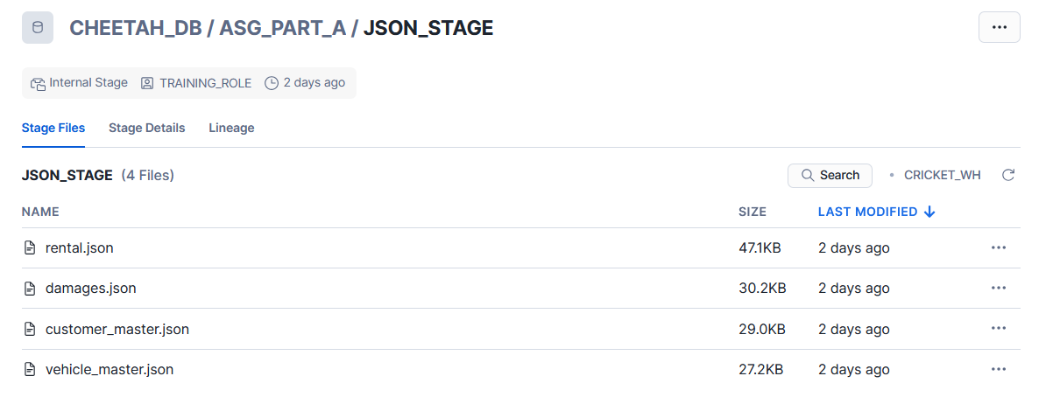

@IMAGES_STAGE
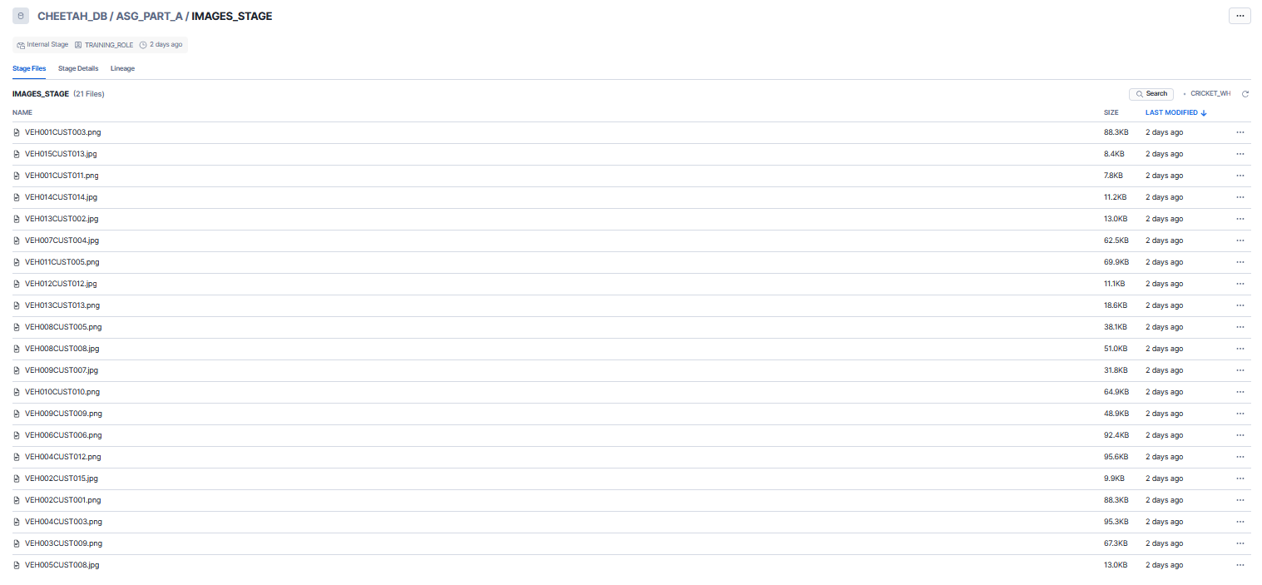
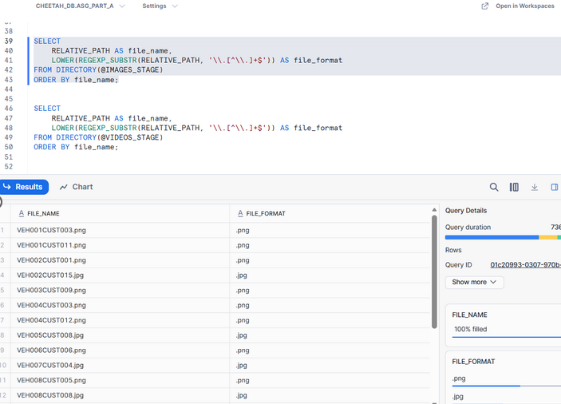

@VIDEOS_STAGE
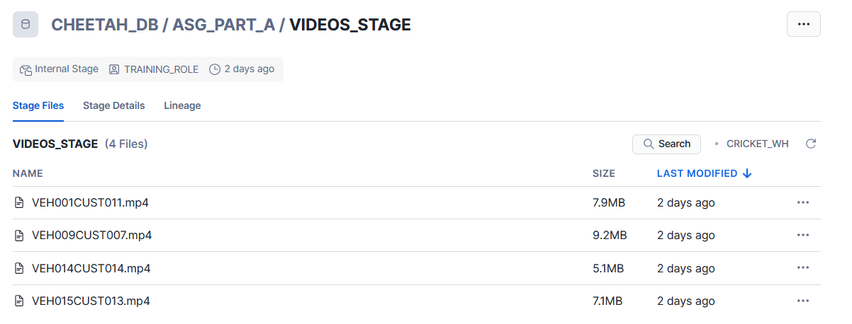
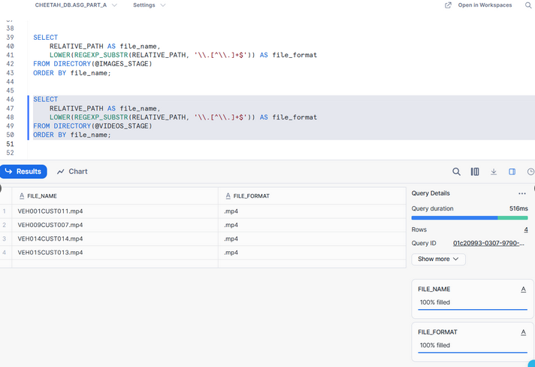

Proof Of File Formats

In Snowflake, a file format tells Snowflake how to interpret and parse JSON files when they are loaded or when querying them from a stage.

For JSON data specifically, a file format defines things like:
- File type is JSON (so Snowflake reads it as semi-structured data into a VARIANT column)
- whether the file is compressed (e.g., GZIP)
- how Snowflake should handle parsing errors (e.g., skip bad records vs fail the load)

JSON file formats are important since Snowflake uses them to read the JSON structure from staged files, so that it can be queried using paths like value:CUSTOMER_ID and allows arrays to be flattened properly.

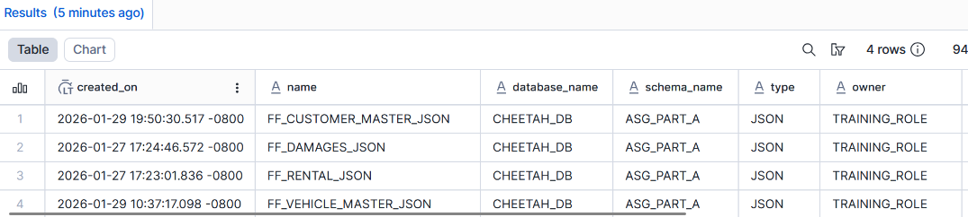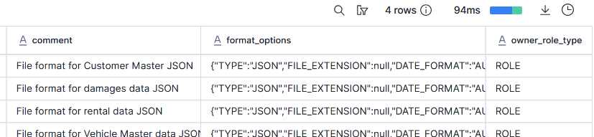

Customer Master
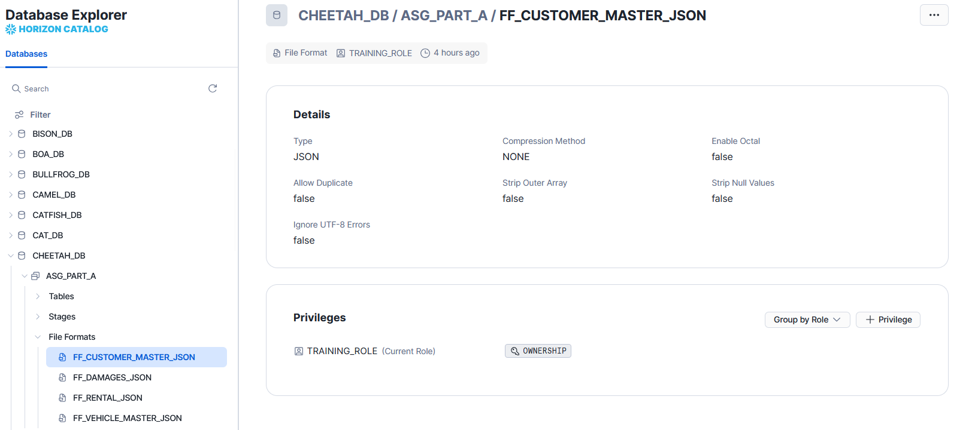

Vehicle Master
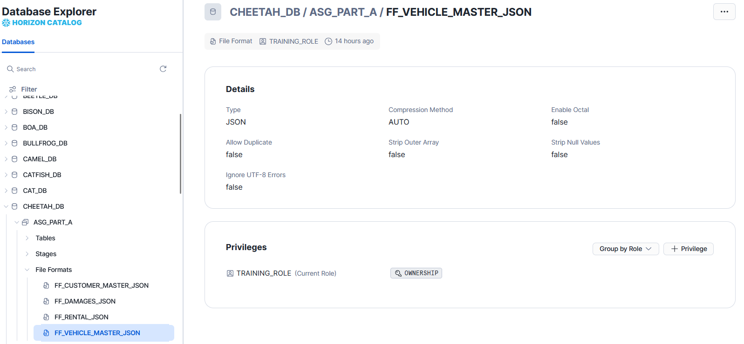

Rental Transaction
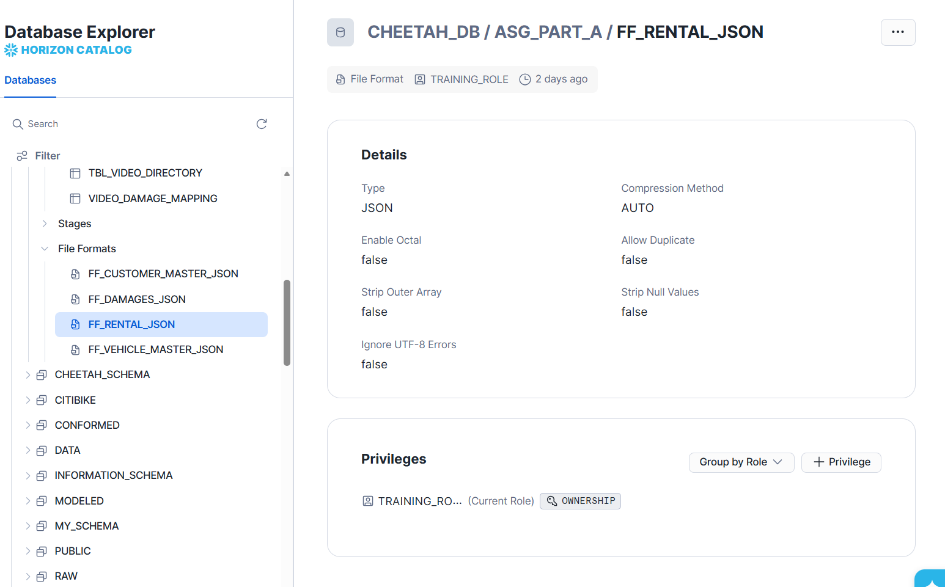

Damage Transaction
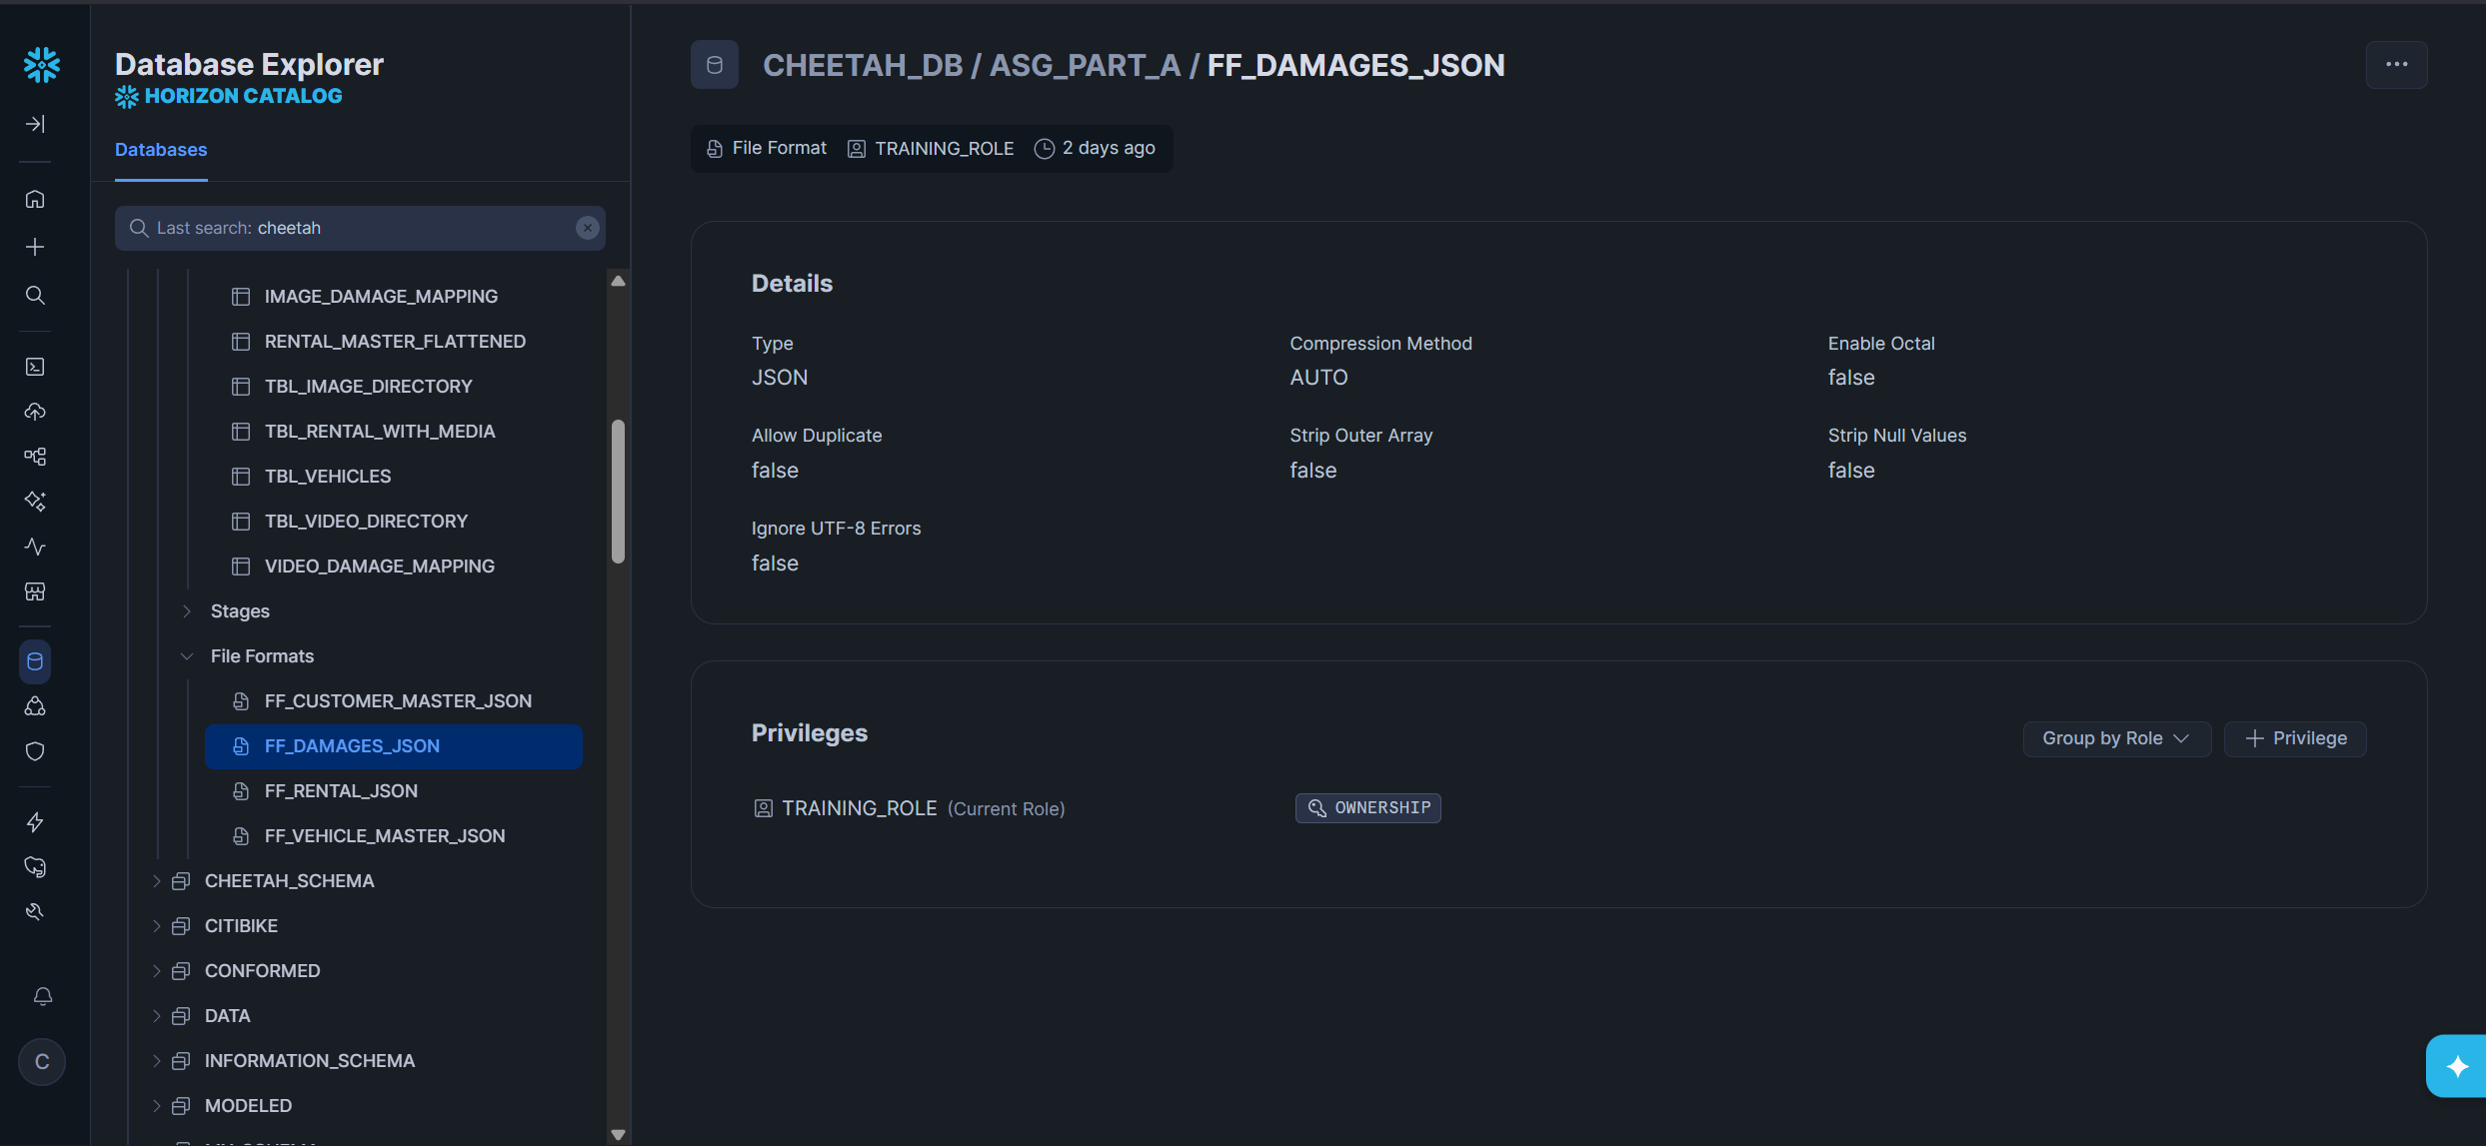

SQL Scripts

Customer Master

Set Context
-- Setting context: ASG Part A Appendix
ALTER SESSION SET QUERY_TAG= '(CHEETAH) - Assignment: Ingestion';
USE ROLE training_role;

ALTER WAREHOUSE CHEETAH_WH
SET WAREHOUSE_SIZE=XSmall;
USE WAREHOUSE CHEETAH_WH;
USE SCHEMA CHEETAH_DB.ASG_PART_A;

This block of code sets the context for which data warehouse, which database and which schema to use. A tag is added to the queries so they can be easily tracked in query history. Objects that are created or queried (tables, views, stages, etc.) will be stored by default to this schema.

Create File Format
CREATE OR REPLACE FILE FORMAT FF_CUSTOMER_MASTER_JSON
TYPE = 'JSON'
COMPRESSION = 'NONE'
STRIP_OUTER_ARRAY = FALSE
COMMENT = 'File format for Customer Master JSON';

This code creates or replaces a Snowflake file format named FF_CUSTOMER_MASTER_JSON that defines how Snowflake should read the Customer Master JSON file. File type is specified as JSON, so Snowflake parses the data into VARIANT. Since JSON files are not compressed (not gzipped, zipped, etc.), no compression method is stated. STRIP_OUTER_ARRAY will prevent the outer JSON array from being removed i.e. CUSTOMERS: [ ].

Create Table By Flattening
-- Create Table As Select (CTAS) by flattening JSON file

CREATE OR REPLACE TABLE CUSTOMER_MASTER_FLATTENED AS
SELECT
-- Customer identifier
cust.value:CUSTOMER_ID::STRING AS Customer_ID,

-- Account metadata
cust.value:ACCOUNT_METADATA.CREATED_DATE::DATE AS Created_Date,
cust.value:ACCOUNT_METADATA.LAST_UPDATED::DATE AS Last_Updated,
cust.value:ACCOUNT_METADATA.STATUS::STRING AS Account_Status,

-- Personal info
cust.value:PERSONAL_INFO.FULL_NAME::STRING AS Full_Name,
cust.value:PERSONAL_INFO.NRIC::STRING AS NRIC,
cust.value:PERSONAL_INFO.DATE_OF_BIRTH::DATE AS DOB,

-- Contact
cust.value:CONTACT.PHONE_NO::STRING AS Phone_No,
cust.value:CONTACT.OFFICE_NO::STRING AS Office_No,
cust.value:CONTACT.EMAIL::STRING AS Email,

-- Emergency contact (array)
ec.value:NAME::STRING AS Emergency_Contact_Name,
ec.value:RELATIONSHIP::STRING AS Emergency_Contact_Relationship,
ec.value:PHONE::STRING AS Emergency_Contact_No,

-- Address
cust.value:ADDRESS.RESIDENTIAL.CITY::STRING AS City,
cust.value:ADDRESS.RESIDENTIAL.POSTAL_CODE::STRING AS Postal_Code,
cust.value:ADDRESS.RESIDENTIAL.COORDINATES.LATITUDE::FLOAT AS Latitude,
cust.value:ADDRESS.RESIDENTIAL.COORDINATES.LONGITUDE::FLOAT AS Longitude,
cust.value:ADDRESS.RESIDENTIAL.GEOHASH::STRING AS Geohash,

-- Geo context
cust.value:ADDRESS.RESIDENTIAL.GEO_CONTEXT.COUNTRY::STRING AS Country,
cust.value:ADDRESS.RESIDENTIAL.GEO_CONTEXT.REGION::STRING AS Region,
cust.value:ADDRESS.RESIDENTIAL.GEO_CONTEXT.PLANNING_AREA::STRING AS Planning_Area,
cust.value:ADDRESS.RESIDENTIAL.GEO_CONTEXT.SUBZONE::STRING AS Subzone,

-- Driver licence
cust.value:DRIVER_LICENCE.LICENCE_NO::STRING AS Licence_No,
cust.value:DRIVER_LICENCE.ISSUE_COUNTRY::STRING AS Issue_Country,
cust.value:DRIVER_LICENCE.ISSUE_DATE::DATE AS Issue_Date,
cust.value:DRIVER_LICENCE.DRIVING_EXPERIENCE.YEARS_OF_EXPERIENCE::INTEGER AS Years_Of_Experience,
cust.value:DRIVER_LICENCE.DRIVING_EXPERIENCE.INTERNATIONAL_PERMIT::BOOLEAN AS International_Permit,

-- Eligible vehicle classes (array)
cust.value:DRIVER_LICENCE.DRIVING_EXPERIENCE.ELIGIBLE_VEHICLE_CLASSES::ARRAY AS Eligible_Vehicle_Class,

-- Verification
cust.value:DRIVER_LICENCE.VERIFICATION.VERIFIED::BOOLEAN AS Licence_Verified,
cust.value:DRIVER_LICENCE.VERIFICATION.VERIFIED_DATE::DATE AS Verified_Date,
cust.value:DRIVER_LICENCE.VERIFICATION.VERIFICATION_METHOD::STRING AS Verification_Method,

-- Insurance
cust.value:INSURANCE_DETAILS.INSURANCE_COMPANY::STRING AS Insurance_Company,
cust.value:INSURANCE_DETAILS.INSURANCE_AGENT::STRING AS Insurance_Agent,
cust.value:INSURANCE_DETAILS.COVERAGE_PLAN.PLAN_NAME::STRING AS Plan_Name,
cust.value:INSURANCE_DETAILS.COVERAGE_PLAN.COVERAGE_AMOUNT::NUMBER AS Coverage_Amount,

-- Risk profile
cust.value:RISK_PROFILE.DEMERIT_POINTS::INTEGER AS Total_Demerit_Points,
cust.value:RISK_PROFILE.RISK_CATEGORY::STRING AS Risk_Category,

-- Traffic offences (array)
t_off.value:OFFENCE_TYPE::STRING AS Offence_Type,
t_off.value:OFFENCE_DATE::DATE AS Offence_Date,
t_off.value:POINTS::INTEGER AS Offence_Points

-- Reference target file: customer_master.json
FROM @JSON_STAGE/customer_master.json (FILE_FORMAT => 'FF_CUSTOMER_MASTER_JSON') src

-- Level 1: customers[]
CROSS JOIN LATERAL FLATTEN(input => src.$1:CUSTOMERS) cust,

-- Level 2: emergency_contacts[]
LATERAL FLATTEN(input => cust.value:CONTACT.EMERGENCY_CONTACTS, OUTER => TRUE) ec,

-- Level 3: traffic_offences[]
LATERAL FLATTEN(input => cust.value:RISK_PROFILE.TRAFFIC_OFFENCES, OUTER => TRUE) t_off;

This CTAS (Create Table As Select) statement creates a relational table called CUSTOMER_MASTER_FLATTENED by reading the customer_master.json file from the internal stage @JSON_STAGE and flattening the nested JSON structure into columns.

It first extracts one row per customer by flattening the top-level CUSTOMERS[] array, then performs additional multi-step FLATTEN operations to expand the nested arrays CONTACT.EMERGENCY_CONTACTS[] and RISK_PROFILE.TRAFFIC_OFFENCES[] into tabular rows. The OUTER => TRUE ensures customers are still returned even if those arrays are missing/empty (values become NULL).

As a result, the output table contains customer attributes (metadata, personal info, address, licence, insurance, risk profile), including emergency contact and traffic offence details, meaning a customer can appear in multiple rows if they have multiple contacts/offences.

Verify All Customer Master Records

SELECT * FROM CUSTOMER_MASTER_FLATTENED;

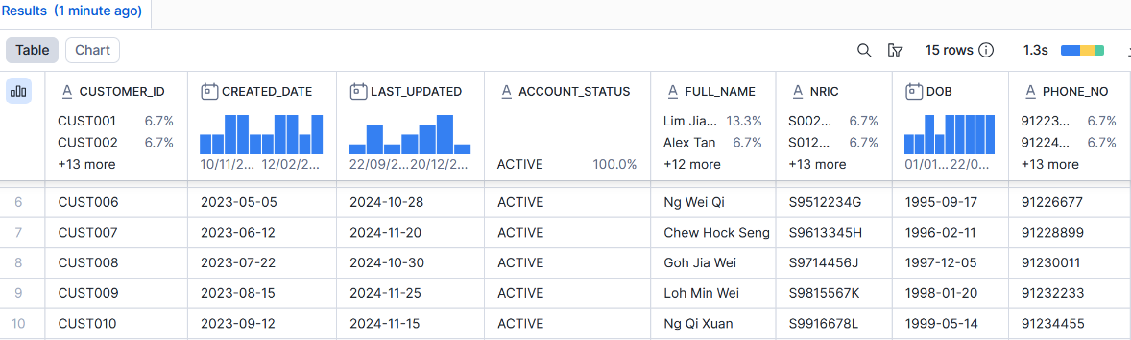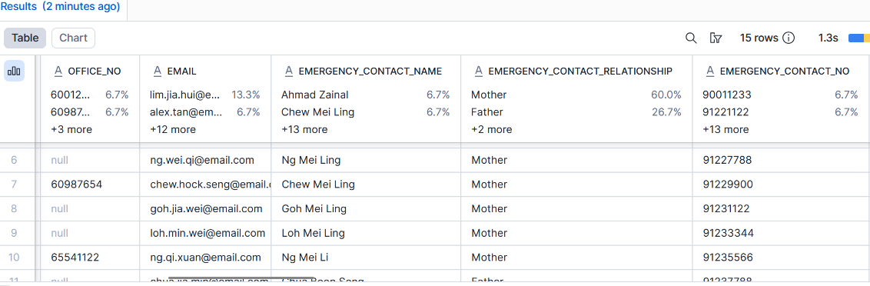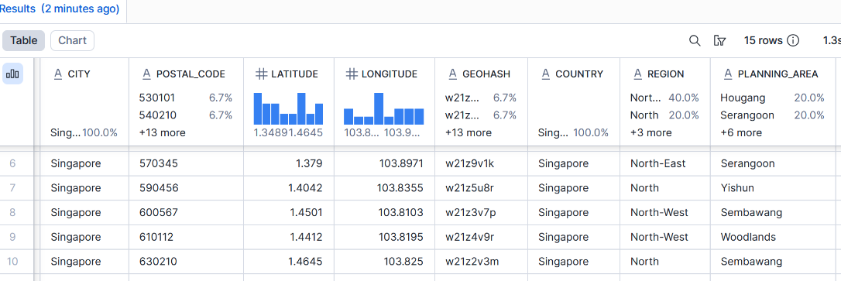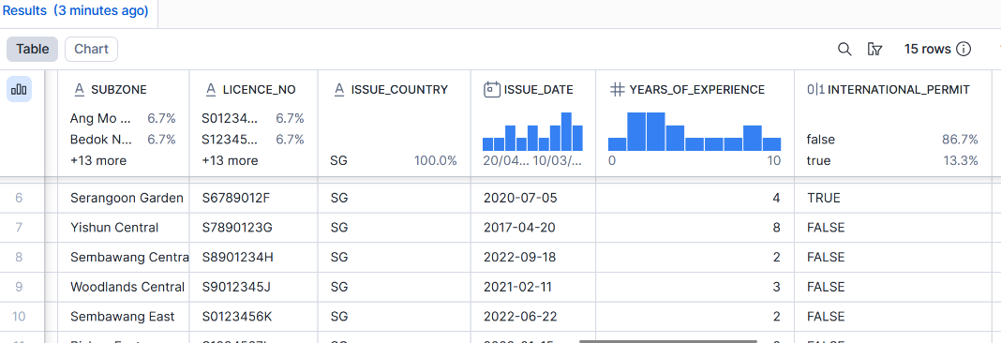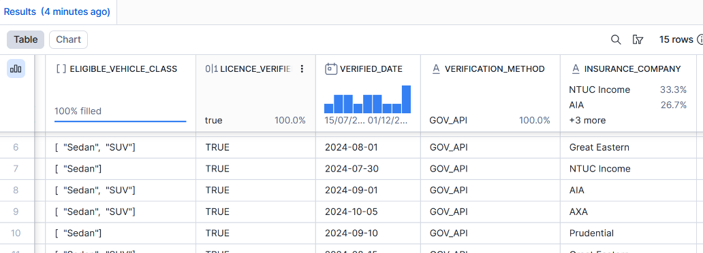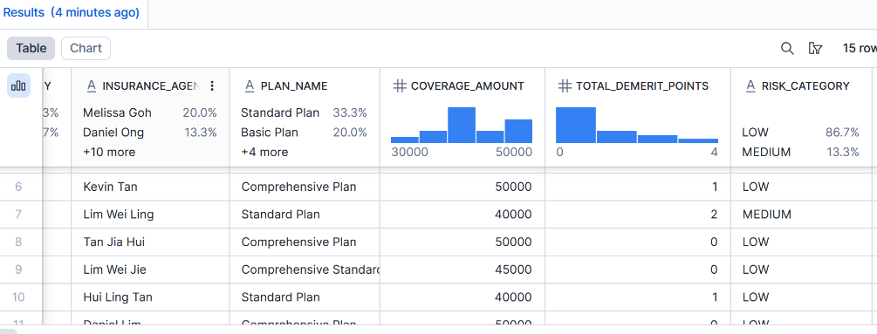
There is a total of 15 records and 40 columns for Customer Master.

Verify Total Record Count

SELECT COUNT(*) AS TOTAL_RECORDS FROM CUSTOMER_MASTER_FLATTENED;

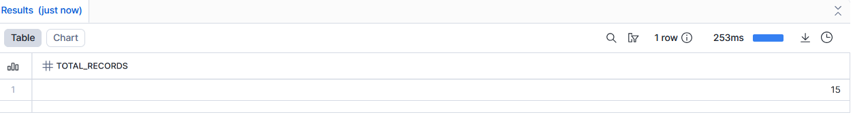

Suspend Warehouse

-- Suspend Warehouse if not working on Snowflake
ALTER SESSION UNSET QUERY_TAG;
ALTER WAREHOUSE CHEETAH_WH SET WAREHOUSE_SIZE = 'XSMALL';
ALTER WAREHOUSE CHEETAH_WH SUSPEND;

Vehicle Master

-- VEHICLE MASTER DATA FLATTENING - CHEETAH

-- File: json_stage/vehicle_master.json

--

-- Set Context

ALTER SESSION SET QUERY_TAG = 'CHEETAH - Assignment: Vehicle Master Flattening';

USE ROLE training_role;

ALTER WAREHOUSE CHEETAH_WH SET WAREHOUSE_SIZE=XSmall;

USE WAREHOUSE CHEETAH_WH;

USE SCHEMA CHEETAH_DB.ASG_PART_A;

-- Create File Format

CREATE OR REPLACE FILE FORMAT ff_vehicle_master_json

TYPE = 'JSON'

STRIP_OUTER_ARRAY = FALSE

COMMENT = 'File format for Vehicle Master data JSON';

-- Flatten Vehicle Master into Table

CREATE OR REPLACE TABLE tbl_vehicles AS

SELECT
-- Level 1: Basic Vehicle Info
v.value:VEHICLE_ID::STRING AS vehicle_id,
v.value:LICENSE_PLATE::STRING AS license_plate,
v.value:BRAND_NAME::STRING AS brand_name,
v.value:MODEL_TYPE::STRING AS model_type,
v.value:MILEAGE_USED::INT AS mileage_used,

-- Level 2: Registration Details
v.value:REGISTRATION_DETAILS.REGISTRATION_YEAR::INT AS registration_year,
v.value:REGISTRATION_DETAILS.VEHICLE_CATEGORY::STRING AS vehicle_category,
v.value:REGISTRATION_DETAILS.FUEL_TYPE::STRING AS fuel_type,

-- Level 2-3-4: Current Location with Geospatial
v.value:CURRENT_LOCATION.DEPOT_NAME::STRING AS depot_name,
v.value:CURRENT_LOCATION.DEPOT_ID::STRING AS depot_id,
v.value:CURRENT_LOCATION.ADDRESS::STRING AS depot_address,
v.value:CURRENT_LOCATION.POSTAL_CODE::STRING AS depot_postal_code,
v.value:CURRENT_LOCATION.COORDINATES.LATITUDE::FLOAT AS depot_latitude,
v.value:CURRENT_LOCATION.COORDINATES.LONGITUDE::FLOAT AS depot_longitude,
v.value:CURRENT_LOCATION.GEOHASH::STRING AS depot_geohash,

-- Level 2-3: Maintenance History

v.value:MAINTENANCE_HISTORY.LAST_SERVICE_DATE::DATE AS last_service_date,
v.value:MAINTENANCE_HISTORY.NEXT_SERVICE_DUE::DATE AS next_service_due,
v.value:MAINTENANCE_HISTORY.SERVICE_CENTER.NAME::STRING AS service_center_name,
v.value:MAINTENANCE_HISTORY.SERVICE_CENTER.COORDINATES.LATITUDE::FLOAT AS service_center_latitude,
v.value:MAINTENANCE_HISTORY.SERVICE_CENTER.COORDINATES.LONGITUDE::FLOAT AS service_center_longitude

FROM @JSON_STAGE (FILE_FORMAT => ff_vehicle_master_json, PATTERN => '.*vehicle_master.json'),

LATERAL FLATTEN(input => $1:VEHICLES) v;

-- Verify the table (should show 5 records)

SELECT * FROM tbl_vehicles LIMIT 5;

-- Count total records

SELECT COUNT(*) AS total_vehicles FROM tbl_vehicles;

-- Check specific vehicle

SELECT * FROM tbl_vehicles WHERE vehicle_id = 'VEH001';

-- Suspend Warehouse

ALTER SESSION UNSET QUERY_TAG;

ALTER WAREHOUSE CHEETAH_WH SET WAREHOUSE_SIZE = 'XSMALL';

ALTER WAREHOUSE CHEETAH_WH SUSPEND;

In Snowflake, a file format tells Snowflake how to interpret and parse JSON files when they are loaded or when querying them from a stage.

Set Context
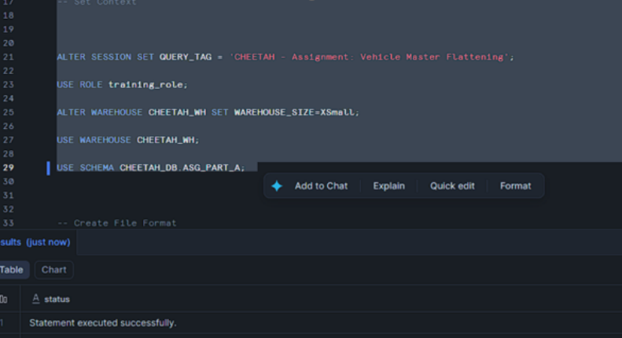
The initial configuration establishes the operational context for the entire data processing workflow. The query tag is set to identify all subsequent operations as part of the Vehicle Master Flattening assignment for the CHEETAH project, which aids in query tracking and performance monitoring within Snowflake's query history. The training role is selected to ensure appropriate access permissions are applied throughout the session, maintaining security and governance standards. The warehouse is configured to use an XSmall size, which provides an optimal balance between computational resources and cost efficiency for this dataset size. The designated schema ASG_PART_A within the CHEETAH_DB database is established as the working environment where all objects will be created and stored.

Create File Format
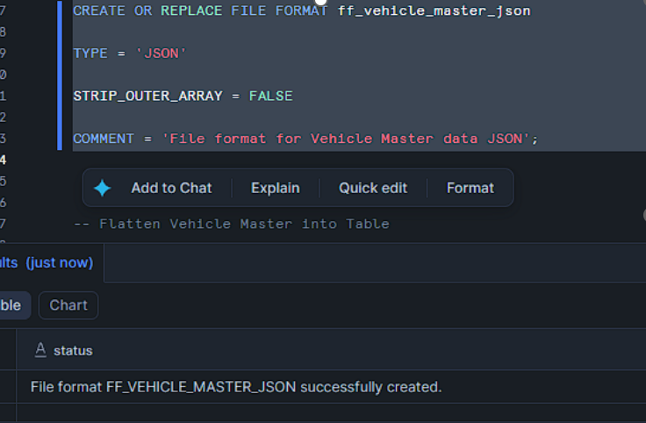
A dedicated file format object is created to handle the specific structural characteristics of the source JSON data. The file format is configured with the JSON type specification to enable Snowflake to correctly parse the incoming data structure. The STRIP_OUTER_ARRAY parameter is set to FALSE because the source data maintains its array structure at the root level with the VEHICLES array containing all vehicle records. This configuration is essential as it instructs Snowflake to preserve the outer array structure during the parsing process, allowing the subsequent LATERAL FLATTEN operation to properly iterate through each vehicle record. The comment attribute provides metadata documentation that clearly identifies this file format's purpose for Vehicle Master data processing.

Flatten Vehicle Master to table
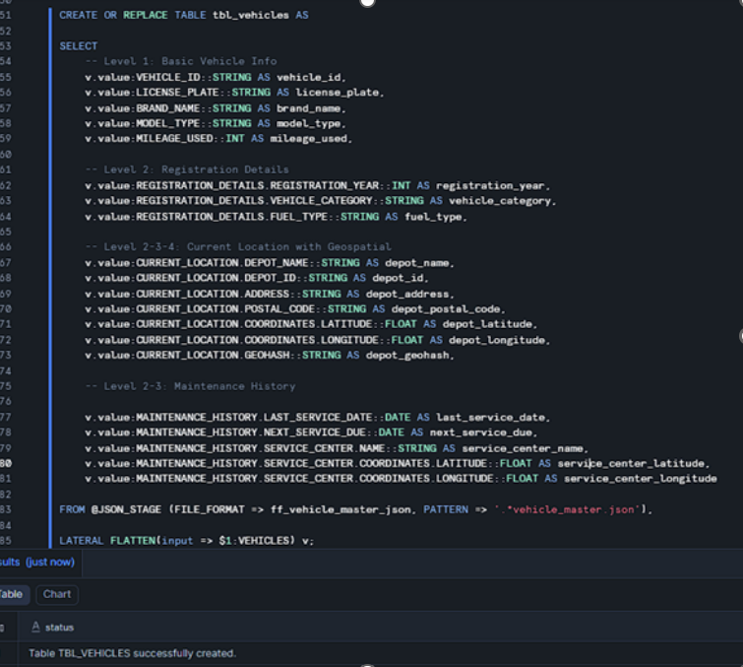
The table creation process employs a sophisticated flattening strategy that transforms the hierarchical JSON structure into a relational tabular format suitable for analytical processing. The CREATE OR REPLACE TABLE statement ensures idempotency, meaning the script can be executed multiple times without causing errors or data duplication. The data source is specified using the @JSON_STAGE location with explicit file format reference and pattern matching to target the vehicle_master.json file specifically.
The LATERAL FLATTEN operation serves as the cornerstone of the flattening process, systematically deconstructing the nested JSON array structure. This operation takes the root-level VEHICLES array and expands it such that each vehicle record becomes accessible as an individual row denoted by the alias 'v'. This transformation is critical because it converts the array-based storage format into a row-based relational format that Snowflake can efficiently query and analyze.
Level 1 Data Extraction - Basic Vehicle Information
The extraction of Level 1 attributes captures the fundamental identifying characteristics of each vehicle. The VEHICLE_ID field is extracted and cast as a STRING data type, serving as the primary unique identifier for each vehicle record in the flattened table. The LICENSE_PLATE attribute similarly undergoes string type casting and represents the official registration plate identifier used for legal and operational tracking purposes. The BRAND_NAME field captures the manufacturer designation, while MODEL_TYPE specifies the particular vehicle model variant. The MILEAGE_USED attribute is extracted and cast as an INTEGER, representing the cumulative distance traveled by the vehicle and serving as a key metric for maintenance scheduling and operational analysis.
Level 2 Data Extraction - Registration Details
The registration information represents the second level of nesting within the source JSON structure. These attributes are accessed through the REGISTRATION_DETAILS object path and provide essential classification and compliance information. The REGISTRATION_YEAR is extracted as an INTEGER value indicating the year the vehicle was officially registered with transport authorities. The VEHICLE_CATEGORY attribute classifies the vehicle into operational categories such as Sedan, SUV, or Luxury Sedan, which is critical for fleet segmentation and analysis. The FUEL_TYPE specification identifies the propulsion system, distinguishing between Hybrid, Petrol, and other fuel technologies, which has implications for operational costs and environmental compliance reporting.
Level 2-3-4 Data Extraction - Current Location with Geospatial Components
The current location attributes represent the most deeply nested structure in the source data, extending through multiple levels of hierarchy. The depot information begins at Level 2 with the CURRENT_LOCATION object, which contains both simple attributes and further nested structures. The DEPOT_NAME and DEPOT_ID fields identify the specific facility where the vehicle is currently stationed, while the ADDRESS and POSTAL_CODE provide the physical location details necessary for logistics and operational planning.
The geospatial coordinates exist at Level 3 within the COORDINATES object nested inside CURRENT_LOCATION. The LATITUDE value is extracted and cast as a FLOAT data type to preserve the decimal precision required for accurate geographic positioning. Similarly, the LONGITUDE coordinate is extracted as a FLOAT, together with LATITUDE forming a coordinate pair that enables precise mapping and spatial analysis capabilities. The GEOHASH attribute, while stored at Level 2 of the CURRENT_LOCATION object, provides an encoded representation of the geographic location using a compact string format that facilitates efficient spatial indexing and proximity calculations.
Level 2-3 Data Extraction - Maintenance History
The maintenance tracking information provides operational intelligence regarding vehicle servicing schedules and service provider details. The MAINTENANCE_HISTORY object at Level 2 contains temporal attributes and a nested service center structure. The LAST_SERVICE_DATE is extracted and cast as a DATE type, documenting when the most recent maintenance activity was completed. The NEXT_SERVICE_DUE field, also cast as DATE, specifies the scheduled date for upcoming required maintenance, enabling proactive service planning and fleet management.
The SERVICE_CENTER information at Level 3 identifies the designated maintenance facility and its location. The NAME attribute specifies the service center's business designation, while the nested COORDINATES object provides the geographic location of the facility. The SERVICE_CENTER_LATITUDE and SERVICE_CENTER_LONGITUDE values are both extracted as FLOAT types, enabling spatial analysis such as calculating distance between vehicle locations and their assigned service centers for logistics optimization.

Verifying table records (sampling 5 records)
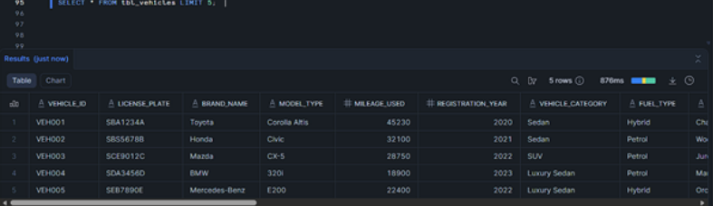
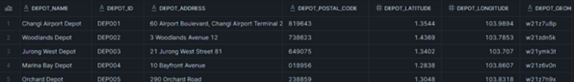
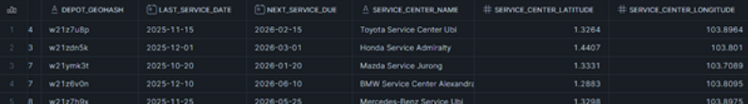
Following the table creation, a series of verification queries ensure data integrity and completeness. The initial SELECT statement with LIMIT 5 provides a sample view of the flattened records, allowing immediate visual inspection of the transformation results. This serves as a quick validation that the flattening logic has correctly extracted and typed all attributes.

Count total records of Vehicle Master

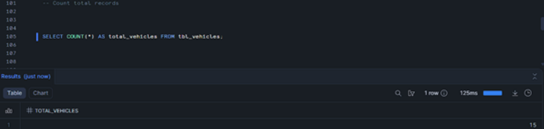
The COUNT query determines the total number of vehicle records successfully loaded into the table, which should match the expected count from the source JSON file. The final verification query targeting a specific VEHICLE_ID allows for detailed examination of a known record to confirm that all nested attributes have been properly flattened and the values match the source data accurately.

Checking a specific vehicle information on Vehicle Master

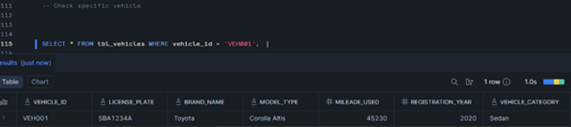
The final verification query targeting a specific VEHICLE_ID allows for detailed examination of a known record to confirm that all nested attributes have been properly flattened and the values match the source data accurately.

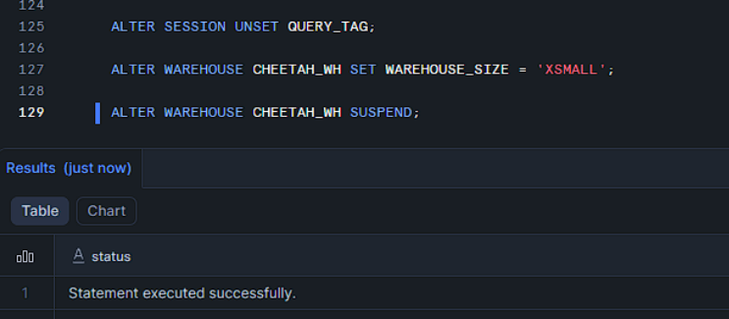

Session Suspend

The concluding operations implement proper resource management practices in the Snowflake environment. The query tag is unset to clear the session identifier, ensuring subsequent operations in the same session are not inadvertently tagged with this assignment identifier. The warehouse size is explicitly reset to XSMALL, confirming the resource allocation matches the intended configuration. Finally, the warehouse is suspended to immediately release computational resources and halt credit consumption.

Rental Transaction
ALTER SESSION SET QUERY_TAG = '(CHEETAH) - Assignment: Ingestion';

USE ROLE training_role;

ALTER WAREHOUSE CHEETAH_WH SET WAREHOUSE_SIZE = XSmall;
USE WAREHOUSE CHEETAH_WH;

USE SCHEMA CHEETAH_DB.ASG_PART_A;

This script sets up the Snowflake working environment before data ingestion begins. It ensures the correct tracking, permissions, compute resources, and schema are used.
CREATE OR REPLACE FILE FORMAT ff_rental_json
TYPE = 'JSON'
STRIP_OUTER_ARRAY = FALSE
COMMENT = 'File format for rental data JSON';

This statement creates or replaces a Snowflake file format named ff_rental_json that defines how JSON rental data files should be interpreted when they are loaded into Snowflake tables.
It ensures that Snowflake correctly understands the structure, hierarchy, and format of the rental JSON files during data ingestion.

TYPE = 'JSON'
- Specifies that the input files are in JSON format
- Tells Snowflake to parse incoming data as semi-structured JSON
- Enables JSON-specific features such as:
  - Nested objects
  - Arrays
  - Key–value access using dot notation

STRIP_OUTER_ARRAY = FALSE
- Indicates that the JSON files do not contain a single top-level array, or that the array should be preserved
- Each JSON object is treated as one complete record
- Important for rental data where:
  - Each file contains a single booking object
  - The full structure must be retained for later flattening

COMMENT = 'File format for rental data JSON'
- Adds a descriptive comment to the file format
- Improves documentation, readability, and maintainability
- Helps other users quickly understand the purpose of the file format
CREATE OR REPLACE TABLE RENTAL_MASTER_FLATTENED AS
SELECT
f.value:BOOKING_ID::STRING AS BOOKING_ID,

f.value:BOOKING_INFORMATION:CUSTOMER_INFO:CUSTOMER_ID::STRING AS CUSTOMER_ID,

TRY_TO_DATE(f.value:BOOKING_INFORMATION:DATES:PICKUP_DATE::STRING) AS PICKUP_DATE,
TRY_TO_DATE(f.value:BOOKING_INFORMATION:DATES:DROPOFF_DATE::STRING) AS DROPOFF_DATE,

f.value:BOOKING_INFORMATION:LOCATION:PICKUP_LOCATION:LOCATION::STRING AS PICKUP_LOCATION,
TRY_TO_DOUBLE(
f.value:BOOKING_INFORMATION:LOCATION:PICKUP_LOCATION:COORDINATES:LATITUDE::STRING
) AS PICKUP_LATITUDE,
TRY_TO_DOUBLE(
f.value:BOOKING_INFORMATION:LOCATION:PICKUP_LOCATION:COORDINATES:LONGITUDE::STRING
) AS PICKUP_LONGITUDE,

f.value:BOOKING_INFORMATION:LOCATION:DROPOFF_LOCATION:LOCATION::STRING AS DROPOFF_LOCATION,
TRY_TO_DOUBLE(
f.value:BOOKING_INFORMATION:LOCATION:DROPOFF_LOCATION:COORDINATES:LATITUDE::STRING
) AS DROPOFF_LATITUDE,
TRY_TO_DOUBLE(
f.value:BOOKING_INFORMATION:LOCATION:DROPOFF_LOCATION:COORDINATES:LONGITUDE::STRING
) AS DROPOFF_LONGITUDE,

f.value:BOOKING_INFORMATION:VEHICLE_TYPE::STRING AS VEHICLE_TYPE,
f.value:BOOKING_INFORMATION:VEHICLE_ID::STRING AS VEHICLE_ID,

TRY_TO_NUMBER(f.value:BOOKING_INFORMATION:PRICE_PER_DAY::STRING, 10, 2) AS PRICE_PER_DAY,
TRY_TO_NUMBER(f.value:BOOKING_INFORMATION:NUMBER_OF_DAYS::STRING) AS NUMBER_OF_DAYS,
TRY_TO_NUMBER(f.value:BOOKING_INFORMATION:TOTAL_PRICE::STRING, 10, 2) AS TOTAL_PRICE,

f.value:BOOKING_INFORMATION:PAYMENT_STATUS::STRING AS PAYMENT_STATUS,
f.value:BOOKING_INFORMATION:REPORT_ID::STRING AS REPORT_ID,
f.value:BOOKING_INFORMATION:ROUTE_ID::STRING AS ROUTE_ID,
f.value:BOOKING_INFORMATION:ZONE_ID::STRING AS ZONE_ID
FROM @JSON_STAGE (FILE_FORMAT => ff_rental_json),
LATERAL FLATTEN(INPUT => $1) f;

This statement creates a new relational table called RENTAL_MASTER_FLATTENED by reading raw rental JSON files from a Snowflake stage, flattening the semi-structured JSON, and transforming nested fields into structured columns.
It converts complex, nested rental booking data into a flat, analytics-ready table suitable for querying, reporting, and downstream processing.

Flattening the JSON structure
LATERAL FLATTEN(INPUT => $1) f
- FLATTEN expands each JSON object into individual rows
- $1 refers to the parsed JSON document
- f.value represents one rental booking record
- Enables access to deeply nested fields using JSON path notation

Booking and customer details
f.value:BOOKING_ID::STRING AS BOOKING_ID
f.value:BOOKING_INFORMATION:CUSTOMER_INFO:CUSTOMER_ID::STRING AS CUSTOMER_ID
- Extracts booking and customer identifiers
- Casts values to STRING for consistency and usability

Rental dates with safe type conversion
TRY_TO_DATE(...PICKUP_DATE...)
TRY_TO_DATE(...DROPOFF_DATE...)
- Converts date strings into proper DATE data types
- TRY_TO_DATE prevents query failure if the date format is invalid
- Invalid values return NULL instead of causing errors

DELETE FROM RENTAL_MASTER_FLATTENED WHERE CUSTOMER_ID IS NULL;

This statement removes invalid or incomplete rental records from the RENTAL_MASTER_FLATTENED table by deleting all rows where the CUSTOMER_ID is missing.
It is a data-cleansing step to ensure only valid, usable rental records remain for analysis and reporting.

Delete from Rental_Master_Flattened
- Specifies the target table from which records will be removed
- Operates directly on the flattened, structured rental master table

Where Customer_ID Is Null
- Filters rows where CUSTOMER_ID has no value
- These records likely:
  - Failed JSON parsing
  - Had missing customer data in the source file
  - Were partially ingested due to data quality issues

SELECT * FROM RENTAL_MASTER_FLATTENED;

ALTER SESSION UNSET QUERY_TAG;

ALTER WAREHOUSE CHEETAH_WH SET WAREHOUSE_SIZE = XSmall;
ALTER WAREHOUSE CHEETAH_WH SUSPEND;

This script verifies the final rental data, cleans up the session configuration, and releases compute resources.
It marks the end of the ingestion and transformation process while ensuring cost-efficient warehouse usage.

Verify the final data
SELECT * FROM RENTAL_MASTER_FLATTENED;
- Retrieves all rows and columns from the flattened rental table
- Used to:
  - Confirm that ingestion and flattening were successful
  - Validate data cleansing (e.g. no NULL customer IDs)
- Acts as a final quality check

Remove the session query tag
ALTER SESSION UNSET QUERY_TAG;
- Removes the previously set QUERY_TAG
- Ensures subsequent queries are not incorrectly tagged
- Helps maintain clean and accurate query tracking

Ensure minimal warehouse size
ALTER WAREHOUSE CHEETAH_WH SET WAREHOUSE_SIZE = XSmall;
- Confirms the warehouse is set to the smallest size
- Prevents unnecessary compute usage
- Good cost-control practice after ingestion is completed

Suspend the warehouse
ALTER WAREHOUSE CHEETAH_WH SUSPEND;
- Stops the warehouse from running
- Immediately halts compute billing
- Ensures no charges accrue when the warehouse is idle

Damage Transaction

ALTER SESSION SET QUERY_TAG = '(CHEETAH) - Assignment: Ingestion';

USE ROLE training_role;

ALTER WAREHOUSE CHEETAH_WH SET WAREHOUSE_SIZE = XSmall;
USE WAREHOUSE CHEETAH_WH;

USE SCHEMA CHEETAH_DB.ASG_PART_A;

The ingestion was run in Snowflake with controlled session tagging, role, warehouse, and schema selection.
- Session tag set to: (CHEETAH) - Assignment: Ingestion
- Role used: training_role
- Warehouse used: CHEETAH_WH
- Warehouse size: XSmall
- Schema used: CHEETAH_DB.ASG_PART_A
This ensures query tracking, correct permissions, predictable compute usage, and objects created in the intended schema.

CREATE OR REPLACE FILE FORMAT ff_damages_json
TYPE = 'JSON'
STRIP_OUTER_ARRAY = FALSE
COMMENT = 'File format for damages data JSON';
A JSON file format was created to correctly parse the staged input files.
Object created:
- File format: ff_damages_json
- Type: JSON
- STRIP_OUTER_ARRAY: FALSE
- Comment: File format for damages data JSON
Reasoning:
- STRIP_OUTER_ARRAY = FALSE means the loader keeps the structure as provided. The script then explicitly uses LATERAL FLATTEN(INPUT => $1) to iterate through the report objects in the JSON content.
CREATE OR REPLACE TABLE DAMAGE_REPORT_MASTER_FLATTENED AS
SELECT
r.value:REPORT_ID::STRING AS REPORT_ID,
r.value:VEHICLE_ID::STRING AS VEHICLE_ID,
r.value:CUSTOMER_ID::STRING AS CUSTOMER_ID,
r.value:BOOKING_ID::STRING AS BOOKING_ID,
TRY_TO_DATE(r.value:DATE::STRING) AS REPORT_DATE,
r.value:REPORTED_BY::STRING AS REPORTED_BY,
r.value:LOCATION::STRING AS LOCATION,
r.value:DAMAGE_TYPE::STRING AS DAMAGE_TYPE,
r.value:DESCRIPTION::STRING AS DESCRIPTION,
r.value:STATUS::STRING AS STATUS,
TRY_TO_NUMBER(r.value:TOTAL_ESTIMATED_LOSS::STRING, 12, 2) AS TOTAL_ESTIMATED_LOSS
FROM @JSON_STAGE (FILE_FORMAT => ff_damages_json),
LATERAL FLATTEN(INPUT => $1) r;
The source JSON is read from the stage:
- @JSON_STAGE
The stage is referenced directly in SELECT statements using:
- FROM @JSON_STAGE (FILE_FORMAT => ff_damages_json)
DAMAGE_REPORT_MASTER_FLATTENED
Purpose:
One row per damage report. This table contains header level information and the total estimated loss.
Created using:
- CREATE OR REPLACE TABLE DAMAGE_REPORT_MASTER_FLATTENED AS
- LATERAL FLATTEN(INPUT => $1) r
Columns produced:
- REPORT_ID, VEHICLE_ID, CUSTOMER_ID, BOOKING_ID
- REPORT_DATE parsed with TRY_TO_DATE
- REPORTED_BY, LOCATION, DAMAGE_TYPE, DESCRIPTION, STATUS
- TOTAL_ESTIMATED_LOSS parsed with TRY_TO_NUMBER(value, 12, 2)
Data quality handling:
- TRY_TO_DATE prevents load failure if date strings are malformed.
- TRY_TO_NUMBER prevents load failure if numeric strings are malformed and returns NULL instead.
CREATE OR REPLACE TABLE DAMAGE_AREAS_FLATTENED AS
SELECT
r.value:REPORT_ID::STRING AS REPORT_ID,
a.value:AREA::STRING AS AREA,
TRY_TO_NUMBER(a.value:SEVERITY::STRING) AS AREA_SEVERITY,
a.value:DAMAGE_TYPE::STRING AS AREA_DAMAGE_TYPE,
TRY_TO_NUMBER(a.value:ESTIMATED_LOSS::STRING, 12, 2) AS AREA_ESTIMATED_LOSS
FROM @JSON_STAGE (FILE_FORMAT => ff_damages_json),
LATERAL FLATTEN(INPUT => $1) r,
LATERAL FLATTEN(INPUT => r.value:AREAS_AFFECTED, OUTER => FALSE) a
WHERE a.value IS NOT NULL;
DAMAGE_AREAS_FLATTENED
Purpose:
One row per affected area within a report. This is a child table keyed by REPORT_ID.
Created using:
- LATERAL FLATTEN(INPUT => r.value:AREAS_AFFECTED, OUTER => FALSE) a
Columns produced:
- REPORT_ID
- AREA
- AREA_SEVERITY parsed with TRY_TO_NUMBER
- AREA_DAMAGE_TYPE
- AREA_ESTIMATED_LOSS parsed with TRY_TO_NUMBER(value, 12, 2)
Filter:
- WHERE a.value IS NOT NULL
This avoids inserting rows when the array element is null.
CREATE OR REPLACE TABLE DAMAGE_ACTIONS_FLATTENED AS
SELECT
r.value:REPORT_ID::STRING AS REPORT_ID,
ac.value:ACTION::STRING AS ACTION,
TRY_TO_DATE(ac.value:DATE::STRING) AS ACTION_DATE,
ac.value:DETAILS::STRING AS ACTION_DETAILS
FROM @JSON_STAGE (FILE_FORMAT => ff_damages_json),
LATERAL FLATTEN(INPUT => $1) r,
LATERAL FLATTEN(INPUT => r.value:ACTIONS_TAKEN, OUTER => FALSE) ac
WHERE ac.value IS NOT NULL;
DELETE FROM DAMAGE_REPORT_MASTER_FLATTENED WHERE REPORT_ID IS NULL;
DAMAGE_ACTIONS_FLATTENED
Purpose:
One row per action taken within a report. This is a child table keyed by REPORT_ID.
Created using:
- LATERAL FLATTEN(INPUT => r.value:ACTIONS_TAKEN, OUTER => FALSE) ac
Columns produced:
- REPORT_ID
- ACTION
- ACTION_DATE parsed with TRY_TO_DATE
- ACTION_DETAILS
Filter:
- WHERE ac.value IS NOT NULL
A cleanup step removes invalid header records:
- DELETE FROM DAMAGE_REPORT_MASTER_FLATTENED WHERE REPORT_ID IS NULL;
This ensures the master table only contains usable primary keys. Note that similar checks were not applied to the child tables. If REPORT_ID can also be null in child rows, additional cleanup could be added there as well.
SELECT * FROM DAMAGE_REPORT_MASTER_FLATTENED;
SELECT * FROM DAMAGE_AREAS_FLATTENED;
SELECT * FROM DAMAGE_ACTIONS_FLATTENED;
Validation was performed by selecting from each table after creation:
- SELECT * FROM DAMAGE_REPORT_MASTER_FLATTENED;
- SELECT * FROM DAMAGE_AREAS_FLATTENED;
- SELECT * FROM DAMAGE_ACTIONS_FLATTENED;
These checks confirm:
- The stage was readable using the JSON file format.
- The flatten logic produced rows.
- Data types were successfully coerced using TRY_TO_DATE and TRY_TO_NUMBER.
Recommended additional validation queries if needed:
- Row counts by table
- Orphan checks between master and child tables
- Null rate checks for key fields
Example:
- SELECT COUNT(*) FROM DAMAGE_REPORT_MASTER_FLATTENED;
- SELECT COUNT(*) FROM DAMAGE_AREAS_FLATTENED;
- SELECT COUNT(*) FROM DAMAGE_ACTIONS_FLATTENED;
- SELECT COUNT(*) FROM DAMAGE_AREAS_FLATTENED a LEFT JOIN DAMAGE_REPORT_MASTER_FLATTENED m ON a.REPORT_ID = m.REPORT_ID WHERE m.REPORT_ID IS NULL;
ALTER SESSION UNSET QUERY_TAG;

ALTER WAREHOUSE CHEETAH_WH SET WAREHOUSE_SIZE = XSmall;
ALTER WAREHOUSE CHEETAH_WH SUSPEND;
The script ends by removing the query tag and suspending compute resources.
- ALTER SESSION UNSET QUERY_TAG;
- ALTER WAREHOUSE CHEETAH_WH SET WAREHOUSE_SIZE = XSmall;
- ALTER WAREHOUSE CHEETAH_WH SUSPEND;
This helps control cost and prevents unnecessary warehouse runtime.

Deliverables Summary
Objects created:
- FILE FORMAT ff_damages_json
- TABLE DAMAGE_REPORT_MASTER_FLATTENED
- TABLE DAMAGE_AREAS_FLATTENED
- TABLE DAMAGE_ACTIONS_FLATTENED
Outcome:
JSON damage reports were successfully ingested from @JSON_STAGE and normalized into three relational tables suitable for reporting and analysis.

Table Joins (Damage)

ALTER SESSION SET QUERY_TAG = '(CHEETAH) - Step 3: Final Curated Join';
USE ROLE training_role;
ALTER WAREHOUSE CHEETAH_WH SET WAREHOUSE_SIZE=XSmall;
USE WAREHOUSE CHEETAH_WH;
USE SCHEMA CHEETAH_DB.ASG_PART_A;

CREATE OR REPLACE TABLE CURATED_DAMAGE AS
SELECT
-- damage master
m.REPORT_ID,
m.VEHICLE_ID,
m.CUSTOMER_ID,
m.BOOKING_ID,
m.REPORT_DATE,
m.REPORTED_BY,
m.LOCATION,
m.DAMAGE_TYPE,
m.DESCRIPTION,
m.STATUS,
m.TOTAL_ESTIMATED_LOSS,

-- Area
a.AREA,
a.AREA_SEVERITY,
a.AREA_DAMAGE_TYPE,
a.AREA_ESTIMATED_LOSS,

-- Action
b.ACTION,
b.ACTION_DATE,
b.ACTION_DETAILS,

-- customer
c.CREATED_DATE,
c.LAST_UPDATED,
c.ACCOUNT_STATUS,
c.FULL_NAME,
c.NRIC,
c.DOB,
c.PHONE_NO,
c.OFFICE_NO,
c.EMAIL,
c.EMERGENCY_CONTACT_NAME,
c.EMERGENCY_CONTACT_RELATIONSHIP,
c.EMERGENCY_CONTACT_NO,
c.CITY,
c.POSTAL_CODE,
c.LATITUDE,
c.LONGITUDE,
c.GEOHASH,
c.COUNTRY,
c.REGION,
c.PLANNING_AREA,
c.SUBZONE,
c.LICENCE_NO,
c.ISSUE_COUNTRY,
c.ISSUE_DATE,
c.YEARS_OF_EXPERIENCE,
c.INTERNATIONAL_PERMIT,
c.ELIGIBLE_VEHICLE_CLASS,
c.LICENCE_VERIFIED,
c.VERIFIED_DATE,
c.VERIFICATION_METHOD,
c.INSURANCE_COMPANY,
c.PLAN_NAME,
c.COVERAGE_AMOUNT,
c.TOTAL_DEMERIT_POINTS,
c.RISK_CATEGORY,
c.OFFENCE_TYPE,
c.OFFENCE_DATE,
c.OFFENCE_POINTS,

-- vehicles
v.LICENSE_PLATE,
v.BRAND_NAME,
v.MODEL_TYPE,
v.MILEAGE_USED,
v.REGISTRATION_YEAR,
v.VEHICLE_CATEGORY,
v.FUEL_TYPE,
v.DEPOT_NAME,
v.DEPOT_ID,
v.DEPOT_ADDRESS,
v.DEPOT_POSTAL_CODE,
v.DEPOT_LATITUDE,
v.DEPOT_LONGITUDE,
v.DEPOT_GEOHASH,
v.LAST_SERVICE_DATE,
v.NEXT_SERVICE_DUE,
v.SERVICE_CENTER_NAME,
v.SERVICE_CENTER_LATITUDE,
v.SERVICE_CENTER_LONGITUDE,

-- images
i.file_path as IMAGE_FILE,
i.IMAGE_URL as IMAGE_URL,

-- video
z.FILE_PATH as VIDEO_FILE,
z.video_url as VIDEO_URL,

-- rental
r.PICKUP_DATE,
r.DROPOFF_DATE,
r.PICKUP_LOCATION,
r.PICKUP_LATITUDE,
r.PICKUP_LONGITUDE,
r.DROPOFF_LOCATION,
r.DROPOFF_LATITUDE,
r.DROPOFF_LONGITUDE,
r.VEHICLE_TYPE,
r.PRICE_PER_DAY,
r.NUMBER_OF_DAYS,
r.TOTAL_PRICE,
r.PAYMENT_STATUS,
r.ROUTE_ID,
r.ZONE_ID

FROM DAMAGE_REPORT_MASTER_FLATTENED m
LEFT JOIN DAMAGE_AREAS_FLATTENED a
ON m.REPORT_ID = a.REPORT_ID
LEFT JOIN DAMAGE_ACTIONS_FLATTENED b
ON m.REPORT_ID = b.REPORT_ID
LEFT JOIN CUSTOMER_MASTER_FLATTENED c
ON m.CUSTOMER_ID = c.CUSTOMER_ID
LEFT JOIN TBL_VEHICLES v
ON m.VEHICLE_ID = v.VEHICLE_ID
LEFT JOIN IMAGE_DAMAGE_MAPPING i
ON m.VEHICLE_ID = i.VEHICLE_ID
AND m.CUSTOMER_ID = i.CUSTOMER_ID
LEFT JOIN VIDEO_DAMAGE_MAPPING z
ON m.VEHICLE_ID = z.VEHICLE_ID
AND m.CUSTOMER_ID = z.CUSTOMER_ID
LEFT JOIN RENTAL_MASTER_FLATTENED r
ON m.BOOKING_ID = r.BOOKING_ID;

Table Joins (Master & Transaction)
CREATE OR REPLACE TABLE CHEETAH_DB.ASG_PART_A.CURATED_DAMAGE AS
WITH
/* 1 row per report */
RPT AS (
SELECT
REPORT_ID,
VEHICLE_ID,
CUSTOMER_ID,
BOOKING_ID,
REPORT_DATE,
REPORTED_BY,
LOCATION,
DAMAGE_TYPE,
DESCRIPTION,
STATUS,
TOTAL_ESTIMATED_LOSS
FROM CHEETAH_DB.ASG_PART_A.DAMAGE_REPORT_MASTER_FLATTENED
),

/* 1 row per customer */
CUST AS (
SELECT
CUSTOMER_ID,
CREATED_DATE,
LAST_UPDATED,
ACCOUNT_STATUS,
FULL_NAME,
NRIC,
DOB,
PHONE_NO,
OFFICE_NO,
EMAIL,
EMERGENCY_CONTACT_NAME,
EMERGENCY_CONTACT_RELATIONSHIP,
EMERGENCY_CONTACT_NO,
CITY,
POSTAL_CODE,
LATITUDE,
LONGITUDE,
GEOHASH,
COUNTRY,
REGION,
PLANNING_AREA,
SUBZONE,
LICENCE_NO,
ISSUE_COUNTRY,
ISSUE_DATE,
YEARS_OF_EXPERIENCE,
INTERNATIONAL_PERMIT,
ELIGIBLE_VEHICLE_CLASS,
LICENCE_VERIFIED,
VERIFIED_DATE,
VERIFICATION_METHOD,
INSURANCE_COMPANY,
PLAN_NAME,
COVERAGE_AMOUNT,
TOTAL_DEMERIT_POINTS,
RISK_CATEGORY,
OFFENCE_TYPE,
OFFENCE_DATE,
OFFENCE_POINTS
FROM CHEETAH_DB.ASG_PART_A.CUSTOMER_MASTER_FLATTENED
QUALIFY ROW_NUMBER() OVER (PARTITION BY CUSTOMER_ID ORDER BY LAST_UPDATED DESC NULLS LAST) = 1
),

/* 1 row per report for rental (dedup in case of multiple) */
RENT AS (
SELECT
REPORT_ID,
CUSTOMER_ID,
BOOKING_ID,
PICKUP_DATE,
DROPOFF_DATE,
PICKUP_LOCATION,
PICKUP_LATITUDE,
PICKUP_LONGITUDE,
DROPOFF_LOCATION,
DROPOFF_LATITUDE,
DROPOFF_LONGITUDE,
VEHICLE_TYPE,
VEHICLE_ID,
PRICE_PER_DAY,
NUMBER_OF_DAYS,
TOTAL_PRICE,
PAYMENT_STATUS,
ROUTE_ID,
ZONE_ID
FROM CHEETAH_DB.ASG_PART_A.RENTAL_MASTER_FLATTENED
QUALIFY ROW_NUMBER() OVER (
PARTITION BY REPORT_ID
ORDER BY DROPOFF_DATE DESC NULLS LAST, PICKUP_DATE DESC NULLS LAST
) = 1
),

/* 1 row per vehicle */
VEH AS (
SELECT
VEHICLE_ID,
LICENSE_PLATE,
BRAND_NAME,
MODEL_TYPE,
MILEAGE_USED,
REGISTRATION_YEAR,
VEHICLE_CATEGORY,
FUEL_TYPE,
DEPOT_NAME,
DEPOT_ID,
DEPOT_ADDRESS,
DEPOT_POSTAL_CODE,
DEPOT_LATITUDE,
DEPOT_LONGITUDE,
DEPOT_GEOHASH,
LAST_SERVICE_DATE,
NEXT_SERVICE_DUE,
SERVICE_CENTER_NAME,
SERVICE_CENTER_LATITUDE,
SERVICE_CENTER_LONGITUDE
FROM CHEETAH_DB.ASG_PART_A.TBL_VEHICLES
QUALIFY ROW_NUMBER() OVER (PARTITION BY VEHICLE_ID ORDER BY NEXT_SERVICE_DUE DESC NULLS LAST) = 1
),

/* 1 row per report per area (this drives the final grain to avoid ambiguous AREA fields) */
AREAS AS (
SELECT
REPORT_ID,
AREA,
AREA_SEVERITY,
AREA_DAMAGE_TYPE,
AREA_ESTIMATED_LOSS
FROM CHEETAH_DB.ASG_PART_A.DAMAGE_AREAS_FLATTENED
),

/* latest action per report to avoid row multiplication */
ACT_LATEST AS (
SELECT
REPORT_ID,
ACTION,
ACTION_DATE,
ACTION_DETAILS
FROM CHEETAH_DB.ASG_PART_A.DAMAGE_ACTIONS_FLATTENED
QUALIFY ROW_NUMBER() OVER (
PARTITION BY REPORT_ID
ORDER BY ACTION_DATE DESC NULLS LAST
) = 1
),

/* latest image per report via (report -> vehicle, customer) mapping, choose most recently modified */
IMG_LATEST AS (
SELECT
r.REPORT_ID,
m.FILE_PATH AS IMAGE_FILE,
m.IMAGE_URL
FROM RPT r
LEFT JOIN CHEETAH_DB.ASG_PART_A.IMAGE_DAMAGE_MAPPING m
ON m.VEHICLE_ID = r.VEHICLE_ID
AND m.CUSTOMER_ID = r.CUSTOMER_ID
LEFT JOIN CHEETAH_DB.ASG_PART_A.TBL_IMAGE_DIRECTORY d
ON d.FILE_PATH = m.FILE_PATH
QUALIFY ROW_NUMBER() OVER (
PARTITION BY r.REPORT_ID
ORDER BY d.LAST_MODIFIED DESC NULLS LAST, m.FILE_PATH DESC
) = 1
),

/* latest video per report via (report -> vehicle, customer) mapping, choose most recently modified */
VID_LATEST AS (
SELECT
r.REPORT_ID,
m.FILE_PATH AS VIDEO_FILE,
m.VIDEO_URL
FROM RPT r
LEFT JOIN CHEETAH_DB.ASG_PART_A.VIDEO_DAMAGE_MAPPING m
ON m.VEHICLE_ID = r.VEHICLE_ID
AND m.CUSTOMER_ID = r.CUSTOMER_ID
LEFT JOIN CHEETAH_DB.ASG_PART_A.TBL_VIDEO_DIRECTORY d
ON d.FILE_PATH = m.FILE_PATH
QUALIFY ROW_NUMBER() OVER (
PARTITION BY r.REPORT_ID
ORDER BY d.LAST_MODIFIED DESC NULLS LAST, m.FILE_PATH DESC
) = 1
)

SELECT
/* report */
r.REPORT_ID,
r.VEHICLE_ID,
r.CUSTOMER_ID,
r.BOOKING_ID,
r.REPORT_DATE,
r.REPORTED_BY,
r.LOCATION,
r.DAMAGE_TYPE,
r.DESCRIPTION,
r.STATUS,
r.TOTAL_ESTIMATED_LOSS,

/* area (final grain is REPORT_ID + AREA) */
a.AREA,
a.AREA_SEVERITY,
a.AREA_DAMAGE_TYPE,
a.AREA_ESTIMATED_LOSS,

/* latest action per report */
act.ACTION,
act.ACTION_DATE,
act.ACTION_DETAILS,

/* customer */
c.CREATED_DATE,
c.LAST_UPDATED,
c.ACCOUNT_STATUS,
c.FULL_NAME,
c.NRIC,
c.DOB,
c.PHONE_NO,
c.OFFICE_NO,
c.EMAIL,
c.EMERGENCY_CONTACT_NAME,
c.EMERGENCY_CONTACT_RELATIONSHIP,
c.EMERGENCY_CONTACT_NO,
c.CITY,
c.POSTAL_CODE,
c.LATITUDE,
c.LONGITUDE,
c.GEOHASH,
c.COUNTRY,
c.REGION,
c.PLANNING_AREA,
c.SUBZONE,
c.LICENCE_NO,
c.ISSUE_COUNTRY,
c.ISSUE_DATE,
c.YEARS_OF_EXPERIENCE,
c.INTERNATIONAL_PERMIT,
c.ELIGIBLE_VEHICLE_CLASS,
c.LICENCE_VERIFIED,
c.VERIFIED_DATE,
c.VERIFICATION_METHOD,
c.INSURANCE_COMPANY,
c.PLAN_NAME,
c.COVERAGE_AMOUNT,
c.TOTAL_DEMERIT_POINTS,
c.RISK_CATEGORY,
c.OFFENCE_TYPE,
c.OFFENCE_DATE,
c.OFFENCE_POINTS,

/* vehicle */
v.LICENSE_PLATE,
v.BRAND_NAME,
v.MODEL_TYPE,
v.MILEAGE_USED,
v.REGISTRATION_YEAR,
v.VEHICLE_CATEGORY,
v.FUEL_TYPE,
v.DEPOT_NAME,
v.DEPOT_ID,
v.DEPOT_ADDRESS,
v.DEPOT_POSTAL_CODE,
v.DEPOT_LATITUDE,
v.DEPOT_LONGITUDE,
v.DEPOT_GEOHASH,
v.LAST_SERVICE_DATE,
v.NEXT_SERVICE_DUE,
v.SERVICE_CENTER_NAME,
v.SERVICE_CENTER_LATITUDE,
v.SERVICE_CENTER_LONGITUDE,

/* media (latest per report) */
img.IMAGE_FILE,
img.IMAGE_URL,
vid.VIDEO_FILE,
vid.VIDEO_URL,

/* rental */
rent.PICKUP_DATE,
rent.DROPOFF_DATE,
rent.PICKUP_LOCATION,
rent.PICKUP_LATITUDE,
rent.PICKUP_LONGITUDE,
rent.DROPOFF_LOCATION,
rent.DROPOFF_LATITUDE,
rent.DROPOFF_LONGITUDE,
rent.VEHICLE_TYPE,
rent.PRICE_PER_DAY,
rent.NUMBER_OF_DAYS,
rent.TOTAL_PRICE,
rent.PAYMENT_STATUS,
rent.ROUTE_ID,
rent.ZONE_ID

FROM RPT r
LEFT JOIN AREAS a
ON a.REPORT_ID = r.REPORT_ID
LEFT JOIN ACT_LATEST act
ON act.REPORT_ID = r.REPORT_ID
LEFT JOIN CUST c
ON c.CUSTOMER_ID = r.CUSTOMER_ID
LEFT JOIN VEH v
ON v.VEHICLE_ID = r.VEHICLE_ID
LEFT JOIN RENT rent
ON rent.REPORT_ID = r.REPORT_ID
LEFT JOIN IMG_LATEST img
ON img.REPORT_ID = r.REPORT_ID
LEFT JOIN VID_LATEST vid
ON vid.REPORT_ID = r.REPORT_ID
;

File Directory / Scoped URLs

Yeaw Min’s version(20/1/2026)
-- Enable directory tracking on stages
ALTER STAGE IMAGES_STAGE SET DIRECTORY = (ENABLE = TRUE);
ALTER STAGE VIDEOS_STAGE SET DIRECTORY = (ENABLE = TRUE);

-- Refresh to see uploaded files
ALTER STAGE IMAGES_STAGE REFRESH;
ALTER STAGE VIDEOS_STAGE REFRESH;

-- Create a table of all images
CREATE OR REPLACE TABLE tbl_image_directory AS
SELECT
RELATIVE_PATH AS file_path, -- File name: "VEH001_exterior.jpg"
SIZE AS file_size_bytes,
LAST_MODIFIED
FROM DIRECTORY(@IMAGES_STAGE);

-- Create a table of all videos
CREATE OR REPLACE TABLE tbl_video_directory AS
SELECT
RELATIVE_PATH AS file_path, -- File name: "VEH001_tour.mp4"
SIZE AS file_size_bytes,
LAST_MODIFIED
FROM DIRECTORY(@VIDEOS_STAGE);

-- Generate URLs for images
SELECT
file_path,
BUILD_SCOPED_FILE_URL(@IMAGES_STAGE, file_path) AS image_url
FROM tbl_image_directory;

-- Generate URLs for videos
SELECT
file_path,
BUILD_SCOPED_FILE_URL(@VIDEOS_STAGE, file_path) AS video_url
FROM tbl_video_directory;

-- Create BUILD_SCOPED_FILE_URL for image
CREATE OR REPLACE TABLE IMAGE_DAMAGE_MAPPING AS
SELECT
FILE_PATH,
BUILD_SCOPED_FILE_URL(@IMAGES_STAGE, file_path) AS image_url,
-- Extract 'VEH' followed by numbers
REGEXP_SUBSTR(FILE_PATH, 'VEH[0-9]+') AS VEHICLE_ID,
-- Extract 'CUST' followed by numbers
REGEXP_SUBSTR(FILE_PATH, 'CUST[0-9]+') AS CUSTOMER_ID
FROM tbl_image_directory;

-- Create BUILD_SCOPED_FILE_URL for video
CREATE OR REPLACE TABLE VIDEO_DAMAGE_MAPPING AS
SELECT
FILE_PATH,
BUILD_SCOPED_FILE_URL(@VIDEOS_STAGE, file_path) AS video_url, REGEXP_SUBSTR(FILE_PATH, 'VEH[0-9]+') AS VEHICLE_ID,
REGEXP_SUBSTR(FILE_PATH, 'CUST[0-9]+') AS CUSTOMER_ID
FROM tbl_video_directory;

Final Curated Dataset
The curated dataset contains tables such as:
- DAMAGE_REPORT_MASTER_FLATTENED (Damage master)
- DAMAGE_AREA_FLATTENED (Damage area)
- DAMAGE_ACTIONS_FLATTENED (Damage actions)
- CUSTOMER_MASTER_FLATTENED (Customer)
- TBL_VEHICLES (Vehicles)
- IMAGE_DAMAGE_MAPPING (Image)
- VIDEO_DAMAGE_MAPPING (Video)
- RENTAL_MASTER_FLATTENED (Rental)

Damage master is being used as a fact table to link all the tables using a left join function by unique identifier. The reason of using left join instead of other joins is that rows that matches from the right table will join to the left tables. For example, Damage master and Damage areas are join by report_id, the report_id in Damage areas that matches the report_id in Damage master will be extracted. This is to prevent having rows full of null values.

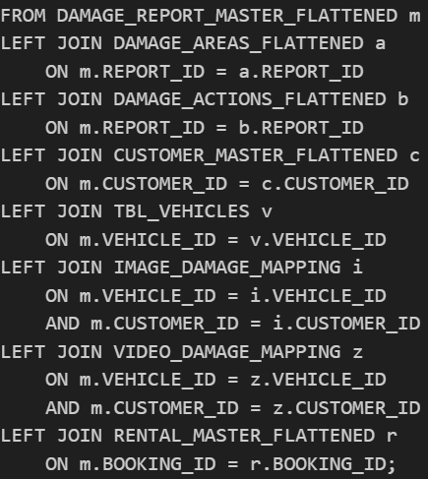

Due to the multiple joins of tables, duplicate records were generated. The ROW_NUMBER () function combines with QUALIFY clause and order by was applied to assign a sequential row number according based on the unique identifier. Records were ordered in descending order and only retain the first row for each unique identifier. This process ensures that only one record per ID is kept, thereby eliminating duplicates while preserving the most up-to-data information. This method improves data integration and guarantees that subsequent analysis is performed on a clean and accurate dataset.

The curated dataset includes all essential information required to analyze rental patterns and assess post-rental vehicle damage using images or video evidence.

76 rows, 69 columns

Exported CSV Snippet
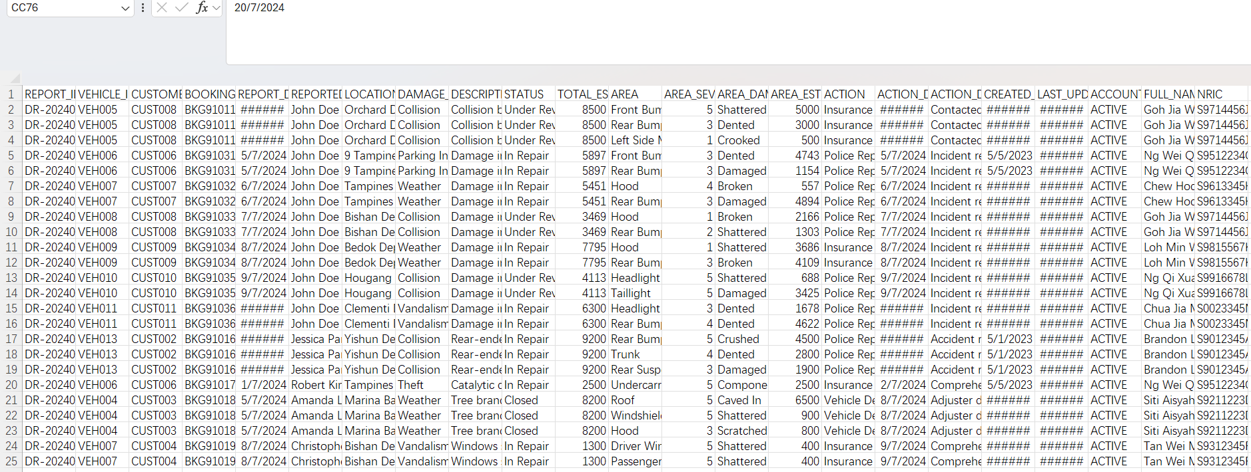

References

Google drive link to images and videos: updated image and files - Google Drive
Images Sourced
VEH001CUST003: Hypothetical: Your 100-150k sports car - ClubLexus - Lexus Forum Discussion
VEH001CUST011: Toyota Corolla Rear-End Collision | Full Trunk & Bumper Repair | Professional Restoration
VEH002CUST015 : damage to honda civic - We-Ha | West Hartford News
VEH003CUST009 : Lamborghini Aventador Crashes in Vancouver
VEH004CUST003: Large tree branch falls onto moving car in Piqua | WDTN.com
VEH004CUST012: Lamborghini Murcielago For Sale
VEH005CUST008: (10) Mercedes-Benz W211 Club Malaysia | Hello everyone. | Facebook
VEH006CUST006: Wrecked 2022 Porsche 911 GT3 Could Be the Most Complicated Project Car Build of the Year - autoevolution
VEH007CUST004: Looters Torch Porsche 911 GT3 RS | by Sam Maven | Motorious | Medium
VEH008CUST005: Car crash compilation from AutoLife # 34
VEH008CUST008: Victoria Car Accident Stock Photos - Free & Royalty-Free Stock Photos from Dreamstime
VEH009CUST007: How to Protect Your Tires from Pothole Damage
VEH009CUST009: Reddit
VEH010CUST010: Scouser who had his car COVERED in paint near airport says "I'll just do it again" - Liverpool Echo
VEH011CUST005: Why Is My Vehicle Overheating? — Steemit
VEH012CUST012: Parts available for a Black 4 door 1.6L 2017 RENAULT KOLEOS DYNAMIQUE S NAV DCI 130 4DR Carrigaline East County Cork Ireland
VEH013CUST002: Jag rev av min stötfångare när jag backade och nu tittar jag på över 4200 dollar i reparationer. : r/Cartalk
VEH013CUST013: Recoveries – MSMS Abogados | Mohorade Serravalle Mainero Santarcángelo
VEH014CUST014: Damaged Audi A4 for sale on oliac autos Japan
VEH015CUST013: 2016 Lexus ES, 300H | JTHBW1GG9G2111899 | Bid History | BidCars
And for the videos .mp4, used capcut to generate the videos.

